THE HOUSE Final test

1. Write the gerund of:
Say –  Love –  Prefer - | Lie –  Cut –  Fry –

2. Describe this house (6 or 7 sentences)
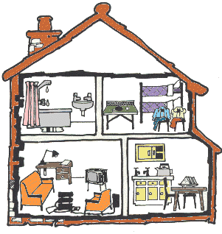

4. Fill the gaps with the appropiate tense:
1. Cristian Souto usually gets up at 8 but today is Sunday so he ..................................
(stay) in bed later.
2. His mother, Noelia, always .................................. (go) to the grocer’s early but
today she is staying at home listening to the radio.
3. Nerea generally goes to the lab but at the moment she .....................................
(read)the newspaper because it is raining.
4. Natalia goes to the hospital every Monday but today it’s Tuesday and she ......
................................. (study) for the English exam.

5. Vocabulary
Arrange-  Complain –  I hope so –  Hill –  Large –  Neighbour – | Murcielago –  Muñeca –  Fantasma –  Abuelito –  Medianoche –  Lengua –

6. Correct the mistakes:
- Today Theodore are reading the newspaper.
- The MacFears skis once a month in the mountains.
- Emma is write letter at the moment.
- There is two big armchairs on the carpet.
- George is composing music every day.
- Georgina smile every day

7. Write a sentence with a preposition of place:

1. 2. 3.
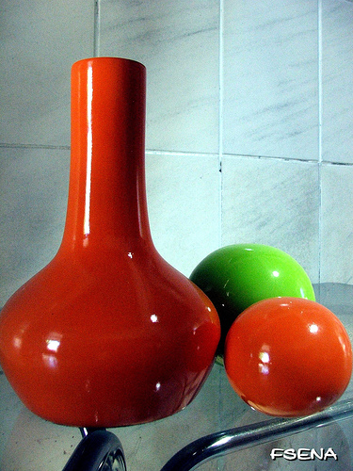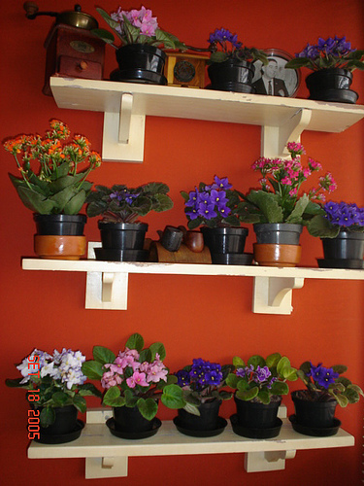

4. 5.


- The green ball is ...................................... the red balls.
- The plants are ........................................ the wall.
- The man is ............................. the cathedal of Santiago.
- The girl .................................... is the same as the girl .....................................
- The ball is ………………………. The box

8. Write what they are doing (Present Continuous). Use the verbs in the box.

brush teeth get dressed cycle shave teach cook
have a shower fish surf laugh

1. 2. 3. 4.


5. 6. 7. 8.


9. 10. 11.


1.
2.
3.
4.
5.
6.
7.
8.
9.
10.
11.

