Name: ___________________ Surnames: ____________________________________
Group: ___________________ Date: _______________________________________

VOCABULARY
1. Write the correct word under each picture. Be careful: there are more words that needed. (10 marks)
BOOTY – BUCANEER – CREW – ENGAGED – GALLEON – GHOST
HANG (verb) – HORIZON – ISLE – JUDGE- KING – OUTLAW – QUEEN
SAILOR – SHORE – SOLDIER - WICKED

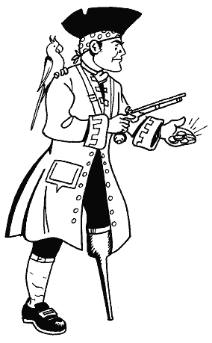 | 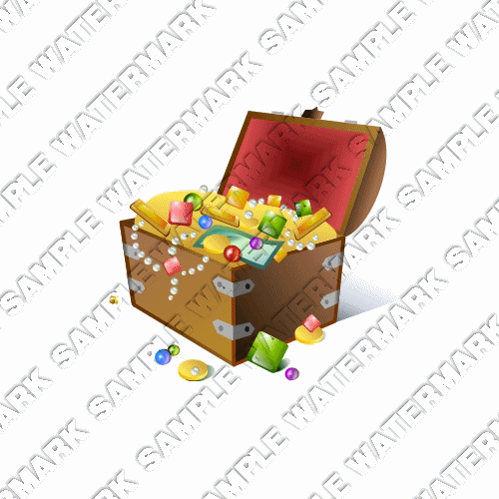 | 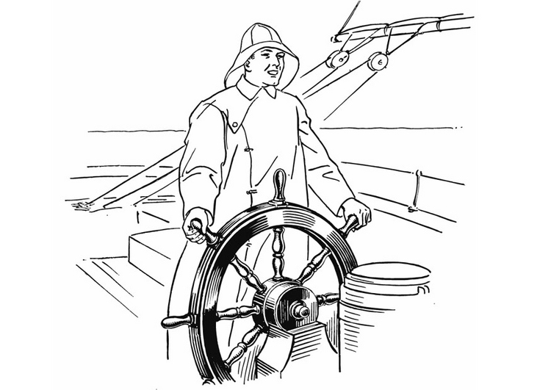 | 
 | 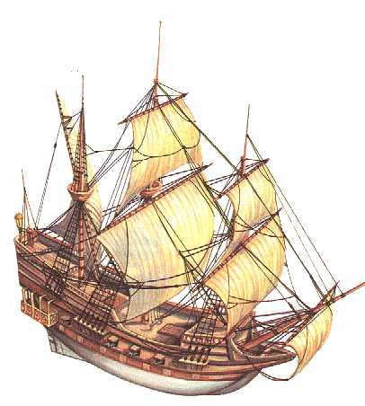 | 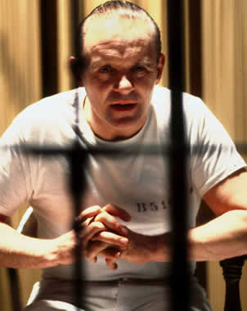 | 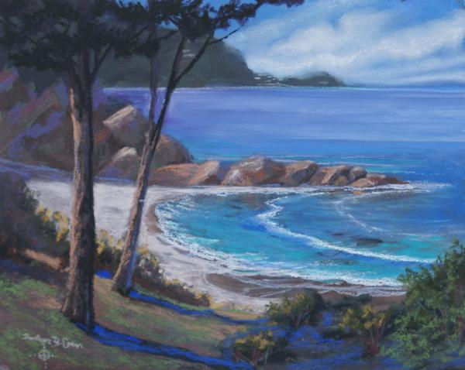
 | 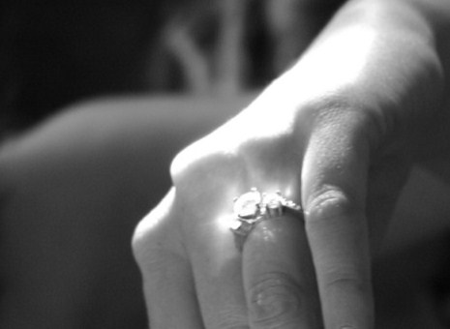 | 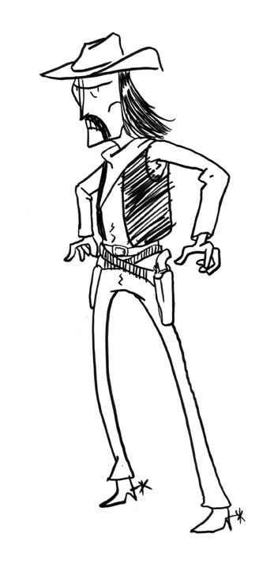

2. Translate the following words into English: (12 marks)
Dramaturgo |  | Autor
Escritor |  | Poema
Poesía |  | Literatura
Obra de teatro |  | Estar enamorado
Teatro |  | Librería
Ingeniero |  | Biblioteca

GRAMMAR

1. Write the past form of the verbs and classify them in the right column.(4 marks
Close – Do – Empty – Enjoy – Fall – Fry – Give – Hope – Kiss – Love – Put - Regret -
Say – Sit – Think - Throw

Regular Verbs | Irregular Verbs

2. Classify these regular verbs according to their final pronounciation. (4 marks)
Burned – Cried – Enjoyed – Listened – Escaped – Dropped – Mixed – Talked Defended – Planted – Presented - Waited

/ d / | / t / | / id /

3. Turn the following sentences into the negative. (14 marks)
a. She was a female pirate. _______________________________________________
b. They led a life of adventure _________________________________________
c. Blackbeard captured a French ship. _______________________________________
d. He died in 1718. _____________________________________________________
e. Charles II forgave him. _______________________________________________
f. Poe wrote a lot of poems _______________________________________________
g. I liked reading adventure books __________________________________________

4. Write questions for each answer. (14 marks)
a. ‘_____________________________________________ ?’’The journey was terrible’
b. ‘______________________________________________?’ ‘We arrived on Monday’
c. ‘_________________________________________?’ ‘The King gave us a new ship’
d. ‘_______________________________________________?’ ‘She went to London?’
e. ‘_________________________________________?’ ‘No, they didn’t see the Queen’
f. ‘_____________________________________________________?’ ‘Yes, they did.’
g. ‘__________________________________________’ ‘I read a good book yesterday’

Turn these sentences into the PAST form: (5 marks)
1. Luisa buys apples at the supermarket. __________________________________________________________
2. They have a great time on their holidays
__________________________________________________________
3. We are happy today.
__________________________________________________________
4. We don’t study French at school.
__________________________________________________________
5. We live in Las Galletas.
__________________________________________________________

WRITING
Write a short composition about what you you did yesterday.

