Name: ___________________ Surnames: ____________________________________
Group: ___________________ Date: _______________________________________

VOCABULARY

VOCABULARY
1. Write the correct word under each picture. Be careful: there are more words that needed. (10 marks)
AMAZING – BUSINESS - DO THE SHOPPING - FORTUNE TELLER- GET WET- HEALTHY – HEART - HOW DO YOU DO - I’M GOING TO GIVE UP MY JOB- MANSION – MARRIAGE - PLAY DARTS – PUBLISH – SHALLOW - WORRIED

 |  | 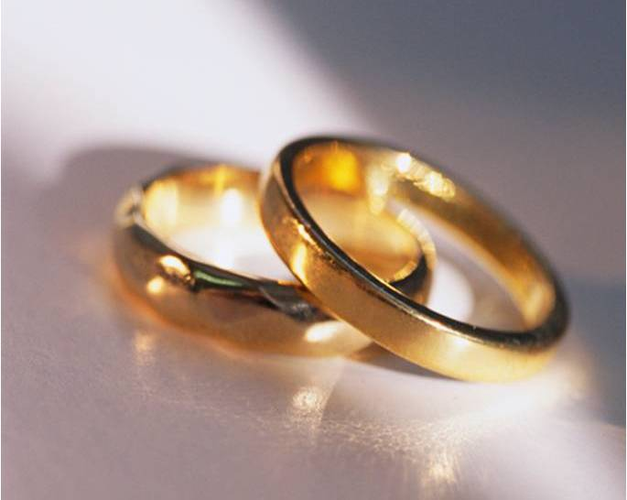 | 
 |  |  | 
 |  | 

2. Write the names of the each finger: (5 marks)


GRAMMAR

1. Write sentences with BE GOING TO. (6 marks)
a. When / you/ play/ football? _____________________________________________________
b. The students/ not/ do/ an English exam tomorrow. ____________________________________
c. I/ study/ at home/ this afternoon. _________________________________________________
d. My sister/ watch/ a video/ tonight. _________________________________________________
e. you/ go/ to London/ next year? ___________________________________________________
f. Where/ she/ meet/ her boyfriend? ____________________________________________________

2. Complete the conversations with these words: (5 marks)
Will open - will buy - will stay - will help - won’t forget
  - What are you going to do today?
I think I _______________ at home all the afternoon..
b. Did you buy the newspaper?
Oh no, I forgot. I _______________ it this afternoon.
c. Can you help me, please? I can‘t open this door.
Of course. I _________________ it for you.
d. Remember to bring the drinks!
OK, I ____________!
e. I can’t carry everything!
Ok, Mum, I _______________ you.

3. Complete with the correct form of WILL or BE GOING TO. (16 marks)
a. In the future, wars ____________________ (disappear)
b. I can’t play the game this week because I _________________(visit) my parents.
c. I think I __________________(not/ pass) this English exam.
d. - Where __________ you _________________(travel) next summer?
– I ____________________(go) to the USA.
f. I __________________(cook) the dinner for you.
g. - Look! That house is on fire!
- Oh my God! I ________________(call) the fire brigade immediately.
h. They ________________________(marry) tomorrow.

4. Complete the sentences using the correct form of the verbs. (12 marks)
1. If your mother ________________(see) you, she ________________(not like) what you are doing.
2. My brother ___________________(fail) if he __________________(not study)
3. If we __________________ (find) a good house, we ________________(marry) in July.
4. Your friends ____________(get) angry if you ________________(give) them their money
5. ________you _________(buy) me a newspaper if you ____________(go) to the shop?
6. I _________________(not give) her the keys if she ______________(ask) me.

