NAME: ____________________________ GROUP: ________ DATE: _________
HOJA DE SEGUIMIENTO 2.

FORTUNE TELLER
II. YOUR TURN
SPEAKING

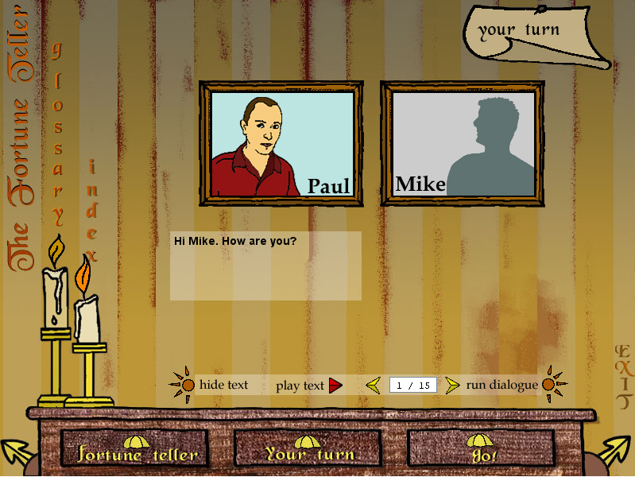

This is Paul’s part in another dialogue. Write your own answers for Mike’s part.

Paul | Mike
- Hi Mike, how are you? | -
- You look really happy today. Why? | -
- Really? Are you sure about that? Marriage is a very serious thing. | -
- Are you going to see her now? | -
- That’s a very good idea. But why are you looking at me like that? It’s very suspicious…. | -
- A surprise for me? Tell me, I can’t wait to hear it. | -
- Who? Me? Am I going to be your best man in the wedding? Oh, thank you very much. I am so pleased!! When is the wedding? | -
- Congratulations, Mike. | -

