NAME: ____________________________ GROUP: ________ DATE: _________

HOJA DE SEGUIMIENTO 4.

PIRATES.

IV. LISTENING + V WRITING

- Complete the blanks to check your answers:

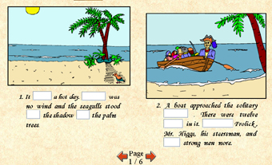 | 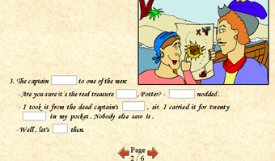
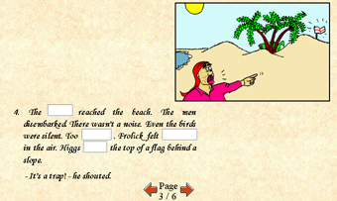 | 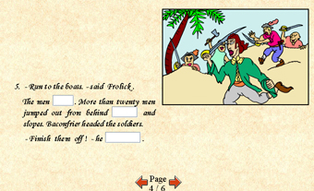
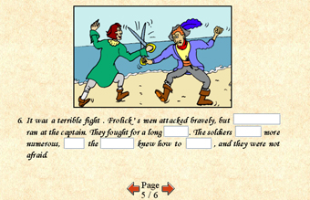 | 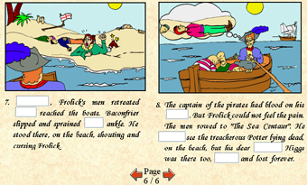

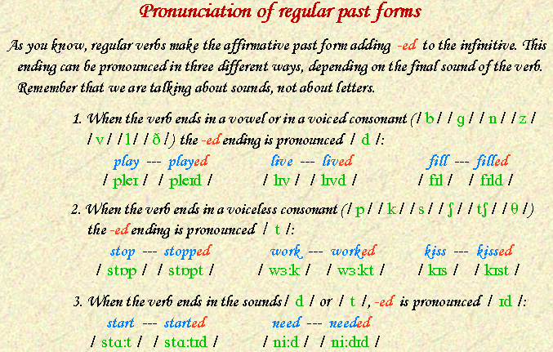

2. Classify the following verbs according to their final sounds:
COLLECTED - KISSED - BURNED - REPAIRED - INVENTED - SMOKED MEASURED - FINISHED - ESCAPED - USED - VISITED - REPEATED ASKED ANSWERED – WATCHED - PRINTED - CLEANED – SAVED SLIPPED – DECIDED GRADUATED - KILLED – CLOSED – CRACKED - WAITED

/ d / | / t / | / id /

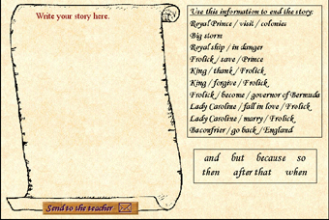

Write your story and send it to the teacher to this email address: segundo_bach_2009@hotmail.com

Comenta de forma breve tus impresiones esta sección tanto en sus aspectos positivos como negativos.



KEY
/ d / | / t / | / id /
advised (ad’vaiz) + d  agreed  allowed  answered  appeared  arrived  believed  belonged  burned  called  carried  changed  cleaned  closed  covered  cried  damaged  described  died  dried  earned  encouraged  enjoyed  entered  explained  explored  filled  followed  happened  interviewed  imagined  jailed  killed  listened  lived  loved  measured  moved  opened  planned  played  performed  pulled  realized  remembered  rained  repaired  saved  shared  shaved  showed  signed  slammed  stayed  snowed  studied  tried  traveled  turned  used  welcomed  whispered  worried  yawned | asked  baked  brushed  cooked  cracked  crashed  danced (da:ns) + t  dressed  dropped  escaped  finished  fixed  guessed  helped  hoped  hiked  joked  jumped  knocked  kissed  laughed (læf) + t  locked  looked  missed  mixed  packed  passed  picked  pressed  pushed  pronounced  relaxed  slipped  smoked  stopped  shopped  talked  typed  walked  washed  watched  worked | attended  arrested  collected  contacted  counted  decided  defended  demanded  divided  ended  expanded  expected  exported  flooded  graduated  hated  hunted  included  invited  invented  landed  needed  painted  planted  printed  presented  pretended  protected  provided  rented  repeated  reported  respected  rested  scolded  skated  started  shouted  treated  visited  waited  wanted  wasted

/ d / | / t / | / id /
answered  burned  closed  cleaned  killed  measured  repaired  saved  used | asked  cracked  escaped  finished  kissed  slipped  watched  smoked | collected  decided  graduated  invented  printed  waited  repeated  visited

