NAME: ____________________________ GROUP: ________ DATE: _________
HOJA DE SEGUIMIENTO 2.

PIRATES.
II. GRAMMAR
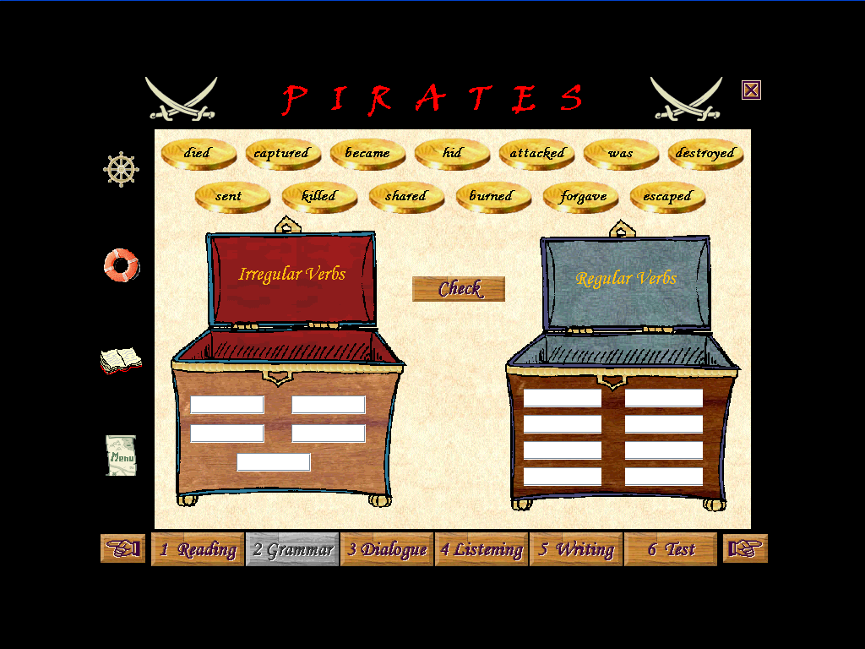

1. What is the infinitive form of the irregular vebs that appear in this exercise? And the past participle? And their translation? Complete the chart.

INFINITIVE | PAST SIMPLE | PAST PARTICIPLE | TRANSLATION
 | Became
 | Hid
 | Was / _ _ _ _ _ _
 | Sent
 | Forgave

2. Write one sentence using the past forms of the irregular verbs in exercise 1.
a. ____________________________________________________________________
b._____________________________________________________________________
c. ____________________________________________________________________
d. ____________________________________________________________________
e. ____________________________________________________________________

3. Turn into the negative the following sentences:
a. Lady Caroline loved Lord Baconfrier.
________________________________________________________________
b. Francis Frolick was American.
________________________________________________________________
c. Lord Bridgewater lived in England.
________________________________________________________________
d. Lord Baconfrier wanted to marry Francis Frolick.
________________________________________________________________
e. Francis gave a new name to the American galleon.
________________________________________________________________

4. Write the true positive sentences for exercise 3.
a. ____________________________________________________________________
b. ____________________________________________________________________
c. ____________________________________________________________________
d. ____________________________________________________________________
e. ____________________________________________________________________

5. Write questions for the underlined sections.
a.. Henry Morgan was born in Wales.
________________________________________________________________
b. Blackbeard died in 1718.
________________________________________________________________
c. Ann Bonny married a sailor.
________________________________________________________________
d. The British sent Captain Kidd to the Indies.
________________________________________________________________
e. King Charles II forgave Morgan because he was necessary in the war against Spain.
________________________________________________________________

Comenta de forma breve tus impresiones esta sección tanto en sus aspectos positivos como negativos.



