NAME: ____________________________ GROUP: ________ DATE: _________
HOJA DE SEGUIMIENTO 1.

PIRATES.
I. READING

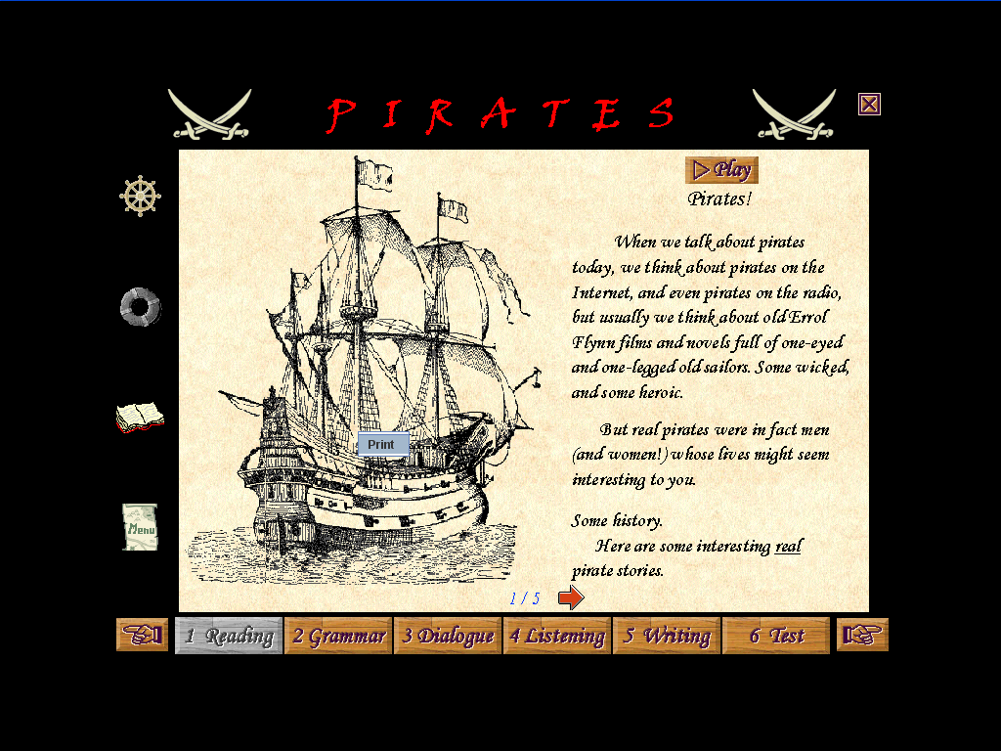

1. What are the texts about? ______________________________________________
________________________________________________________________

2. Did you find the texts difficult or easy? Why? _____________________________ ______________________________________________________________________ ______________________________________________________________________

3. Write three new words about each section that you have learnt after reading the text. Translate them into Spanish.

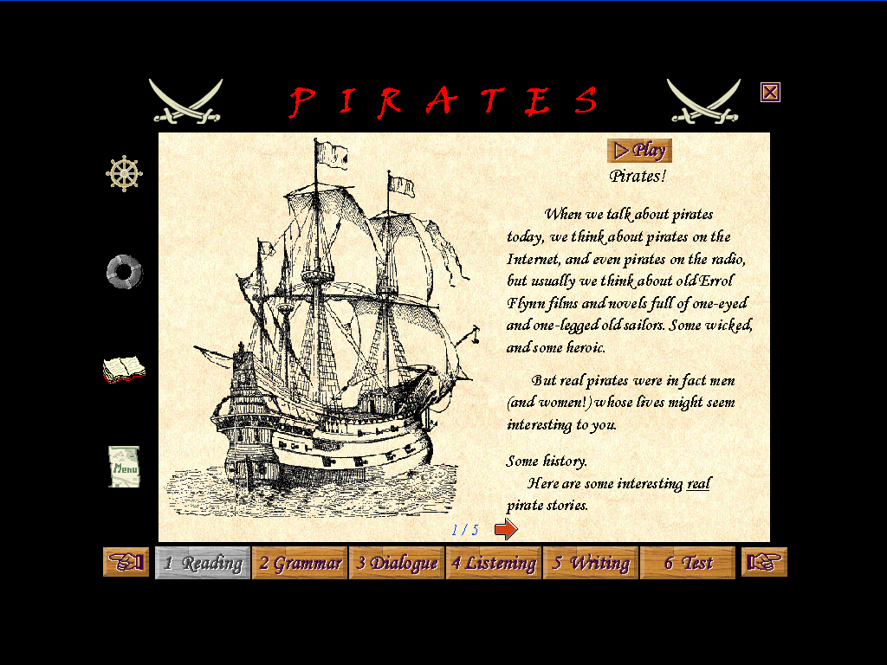 | 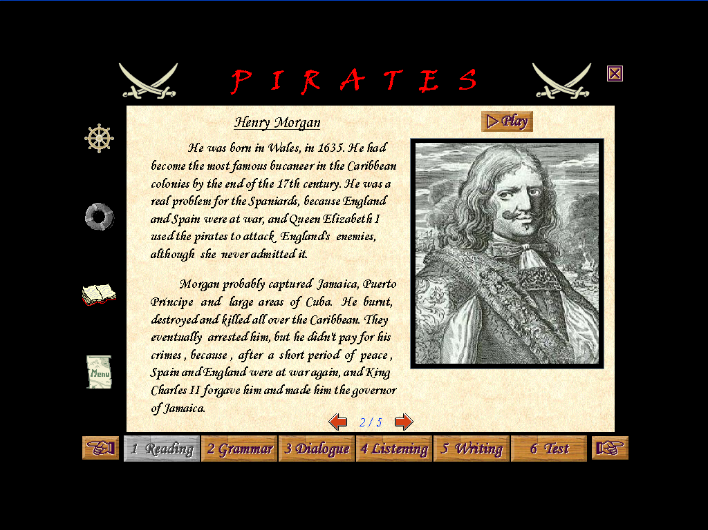 | 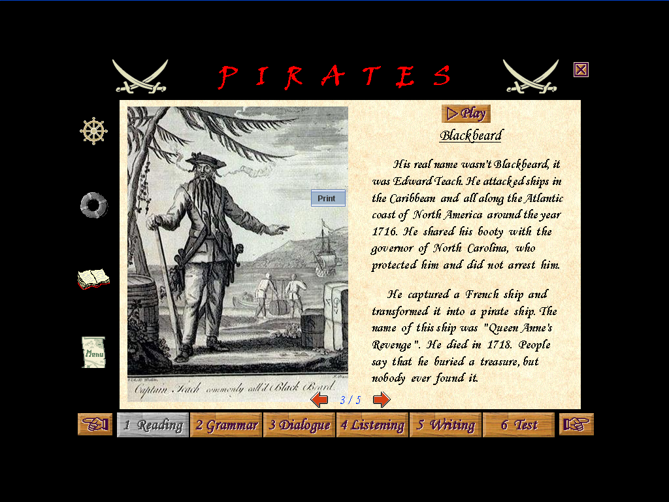 | 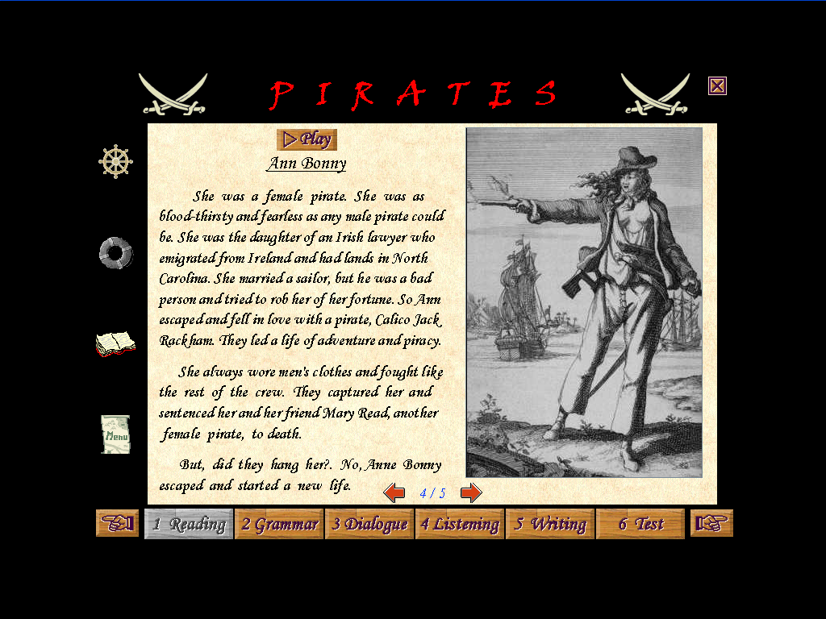 | 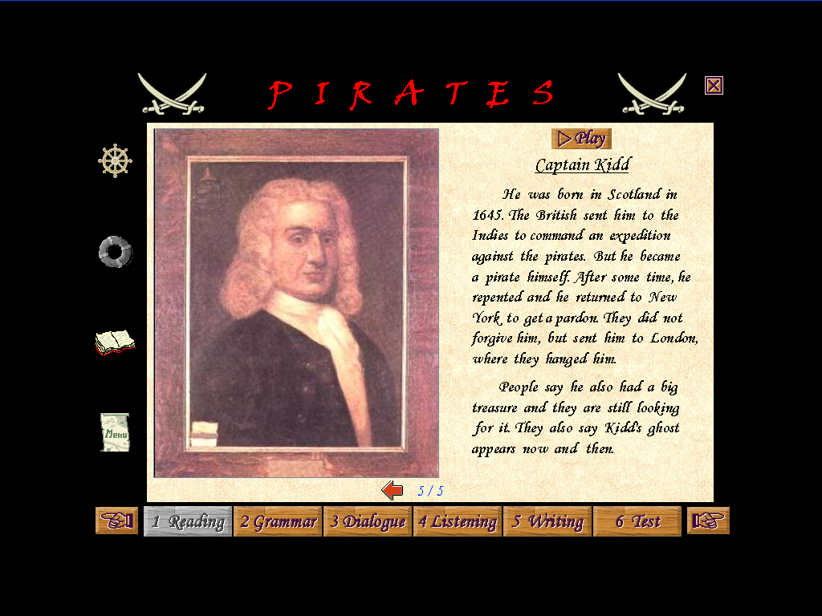

4. Choose only THREE of the words in exercise 3. Write a sentence with each word:
a. ____________________________________________________________________
b. ____________________________________________________________________
c. ____________________________________________________________________

OUR STORY.
- Match each sentence with the characters of our story:

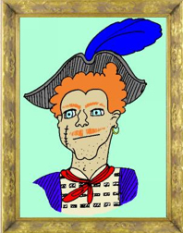  Francis Frolick, a.k.a.  Frank Broken-eyebrow | 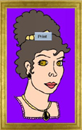  Lady Caroline Bridgewater | 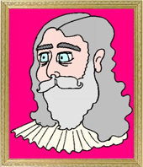  Lord Bridgewater | 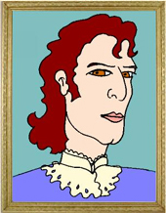  Lord Baconfrier

Sentence | Character?
1. The King sent him to Isabella Island to capture pirates.
2. He was born in England but started a new life in the Caribbean Sea.
3. He was going to marry Lady Caroline.
4. She lived with her father in a plantation.
5. He didn’t like pirates because they robbed his ships.

6. He hated Lord Baconfrier.

7. He captured a Spanish ship and gave her a new name.
8. He was really good with swords.

2. “She was soon the terror of the shores of Isabella Island” Who was ‘she’ ?
__________________________________________________________________________________________________________________________________________________________________________________________________________________

Comenta de forma breve tus impresiones esta sección tanto en sus aspectos positivos como negativos.



