PIRATES

Worksheets 3º E.S.O.

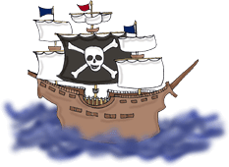

Rosario Toledo Seco
BEFORE YOU START
- What do these icons mean?
…………………………………….
……………………………………….
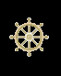 ………………………………………
PART 1: READING
PART ONE. TEXT: PIRATES
ANSWER THESE QUESTIONS WITH THE INFORMATION FROM THE FIRST TEXT?
- Do pirates exist only in films?

- Where can you find “pirates” nowadays?
MATCH THESE STATEMENTS TO THE CORRECT PIRATE (THERE ARE 3 SENTENCES FOR EACH ONE):
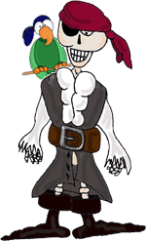
- His ghost appeared now and then
- His real name was Edward Teach
- He was Welsh
- He was Scottish
- This pirate´s father was a lawyer and had lands
- He buried a treasure, but nobody ever found it
- This pirate shared his booty with the governor of Carolina
- This pirate was governor of Jamaica
- She was a female pirate
- He commanded an expedition against the pirates
- He attacked Spanish ships
- This pirate escaped and started a new life

Henry Morgan: ……………. ………………… ………………
Blackbeard: ……………. ………………… ………………
Ann Bonny: ……………. ………………… ………………
Captain Kidd: ……………. ………………… ………………

PART TWO. READING COMPREHENSION.
WRITE DOWN YOUR RESULTS:
Right answers  | Wrong answers  | Total items
 |  | ....... / 8

PART THREE. READ AND LISTEN
LET´S SEE HOW MUCH YOU KNOW ABOUT THE FOLLOWING CHARACTERS.
WHO IS WHO? WRITE THE NAMES OF THE CHARACTERS.
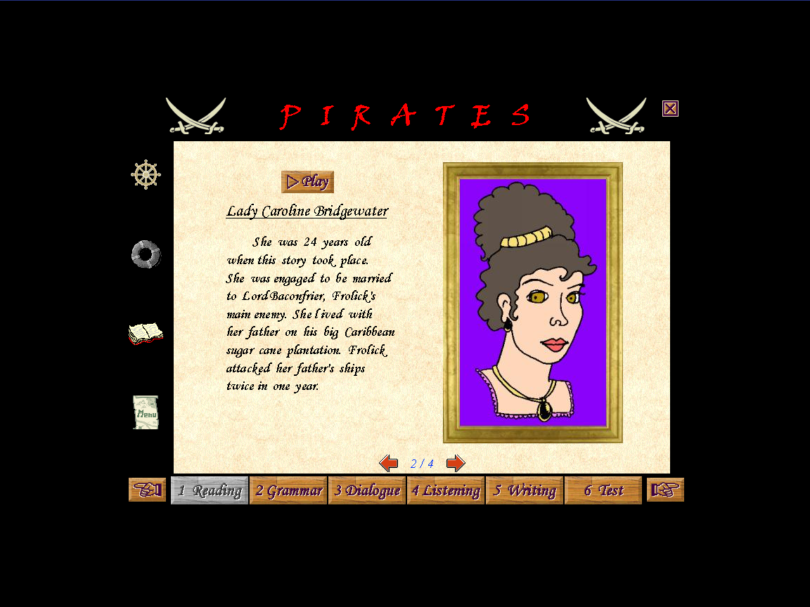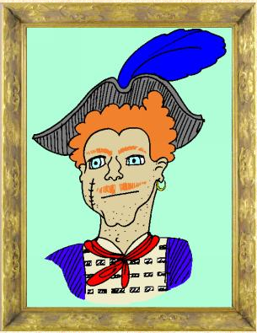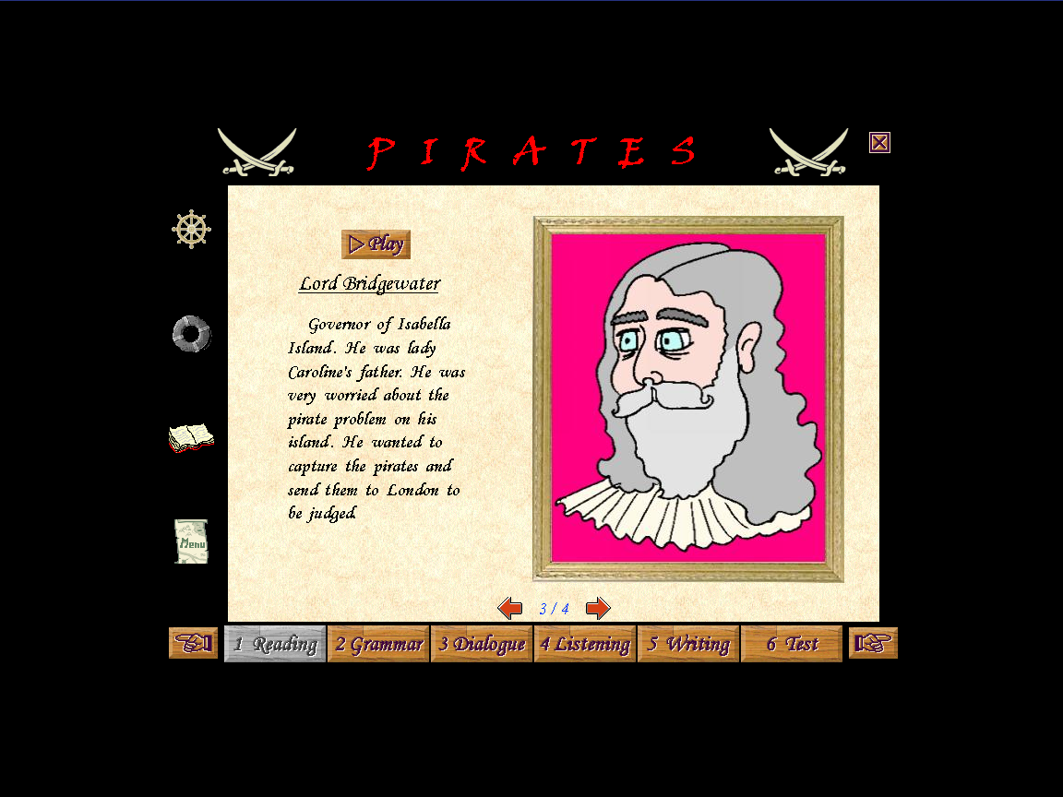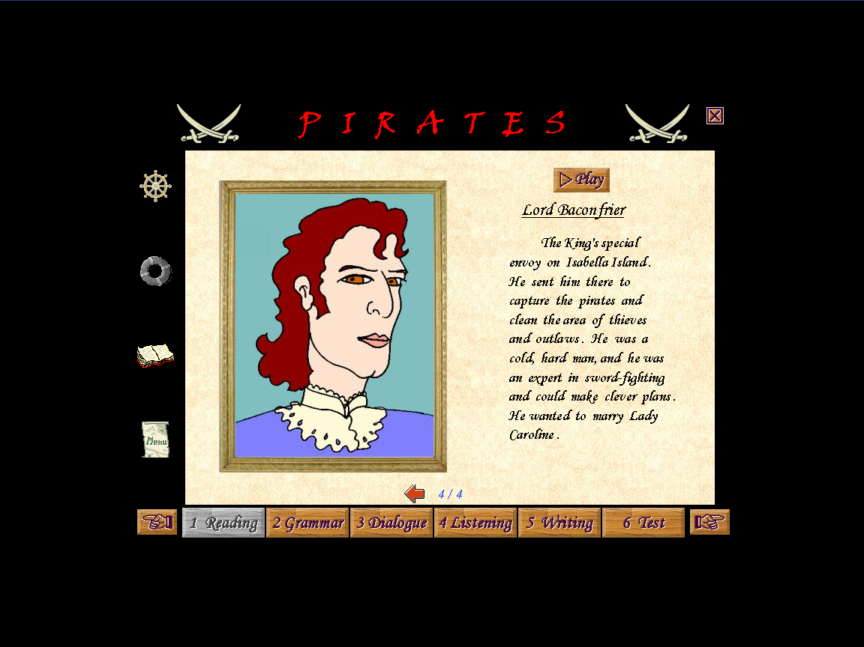
………………………… …………………… …………………. ………………………
ARE THESE SENTENCES TRUE OR FALSE? WHY?
1. Francis Frolick:
a) His nickname was Frank Brokeneyebrow
b) His father robbed him of his property in Dorset
c) He wanted to marry Lady Caroline
- Lady Caroline Bridgewater:
- She was Lord Bridgewater´s wife
- She lived in a big Caribbean wool plantation
- She was 24 years old

- Lord Bridgewater:
- He was governor of Tenerife Island
- He wanted to kill the pirates in the island
- He had a daughter

- Lord Baconfrier:
- He is a good man
- He wanted to marry Lady Caroline Bridgewater
- He worked in the plantation
VOCABULARY
WRITE A SYNONYM OR A SHORT DEFINITION OF THE FOLLOWING:
wicked – cold – outlaw - expert – engaged – island – pirate

WRITE DOWN YOUR RESULTS:
Right answers | Wrong answers | Total items
 |  | ...../ 4

PART 2: GRAMMAR
ONCE YOU HAVE FINISHED THE EXERCISES, FILL IN THESE CHARTS:
REGULAR VERBS
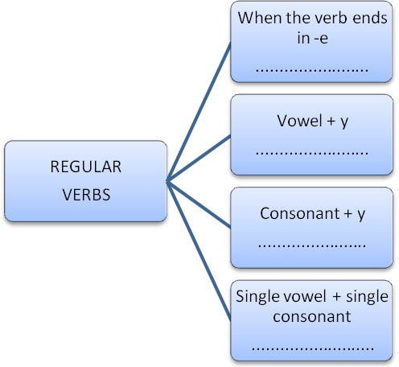
IRREGULAR VERBS
BASE FORM | SIMPLE PAST | MEANING
BREAK
BUY
COME
DO
EAT
FALL
GET
GIVE
GO
HEAR
KNOW
PUT
RUN
SAY
SEE
SIT
THINK
THROW


REVISION OF WH- QUESTIONS: What´s the meaning of the following words?

WHO
WHEN
WHERE
HOW
WHY
FIND THE MISTAKES, CAPTURE THE SCREEN AND STICK IT TO A DOCUMENT YOU MUST SAVE IT IN YOUR PENDRIVE.
PART 3: DIALOGUE
- Say if the sentences are True or False. Write down your results:
Right answers | Wrong answers | Total items
 |  | ..... / 8

- Match the expressions to the pictures. You can listen to the expressions if you click on them. Write down your results:
Right answers | Wrong answers | Total items
 |  | ..... / 5

- Record yourself
PART 4: LISTENING
ASK ONE QUESTION FOR EACH TEXT. For example: TEXT 1 “What was the weather like?”
TEXT 1
TEXT 2
TEXT 3
TEXT 4
TEXT 5
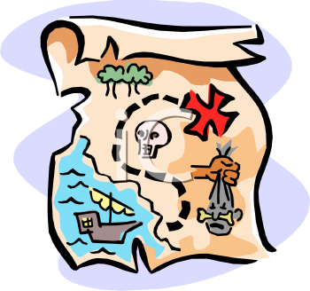
TEXT 6
PART 5: WRITING
WRITE THE STORY AND SEND IT TO YOUR TEACHER:
mtolsec@yahoo.es

PART 5: TESTS
- Find the word for the definition. Game. Write down your results:
Right answers | Wrong answers | Total items
 |  | ..... / 6

- Complete the FINAL TEST. Write down your results:
Right answers | Wrong answers | Total items
 |  | ...../ 24

VOCABULARY (WITH A DICTIONARY: http://www.wordreference.com/ )
1 Write the correct word under each picture:
one-legged / sailor / to hung / pirate flag (Jolly Roger) / seagull / to sink / parrot / steersman / sword-fighting / anchor / female pirate / treasure (booty) / island / skull / map / gun / rowing-boat / galleon /one-eyed (patch) / ghost

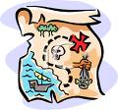

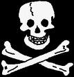





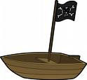


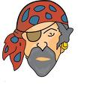

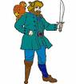

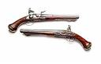

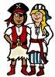
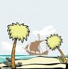

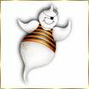

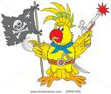

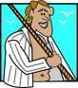

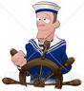





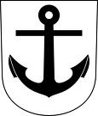

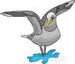

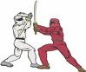

2 Classify the following words:
GALLEON / DAMNED / BUCANEER / WICKED / SAILOR / HEROIC / SHOONER / STEERSMAN / BLOODY-THIRSTY / CARAVEL / CAPTAIN / SCOUNDREL / FEARLESS / FRIGATE / TREACHEROUS / OUTLAW / PIRATE / ROWINGBOAT / CREW / BRIGANTINE
ADJECTIVES | SHIPS | MEN OF THE SEA

3 In pairs, do the following activity, “Pirates Treasure Hunt”: http://www.rochedalss.eq.edu.au/mapp.htm

