Worksheets 3º ESO

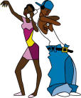

Mª Rosario Toledo Seco
THE LOOK
PRE-READING
WHAT DO THESE TWO ICONS MEAN?
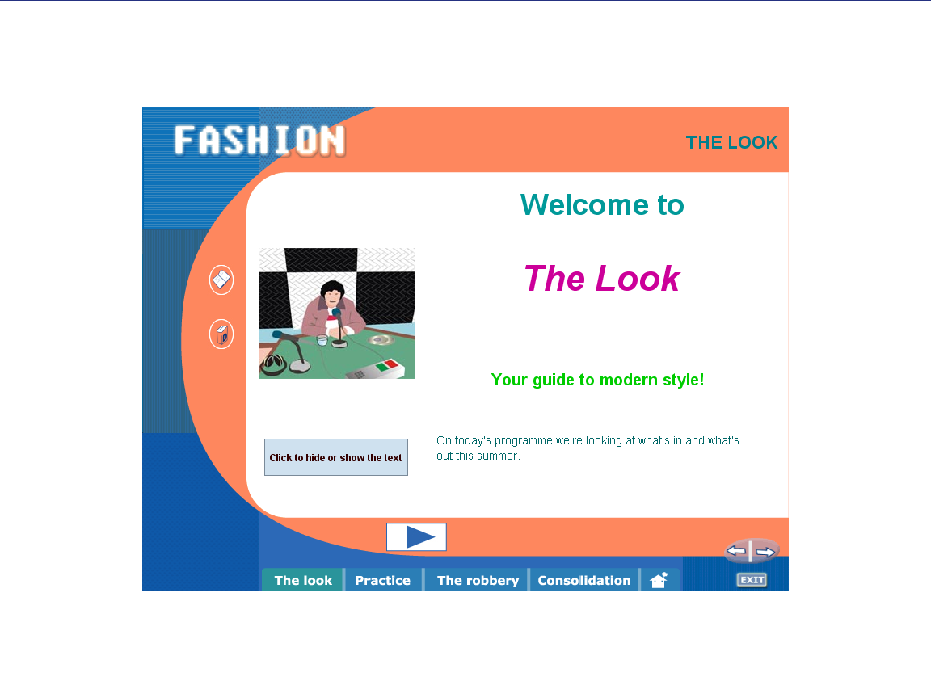
VOCABULARY: Once you have finished the exercise, choose two items for each picture (Don´t look at the screen!)
1.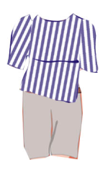 2.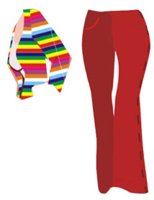 3. 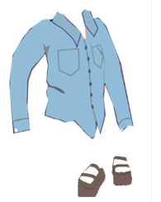 4. 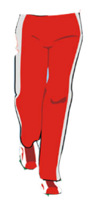
5. 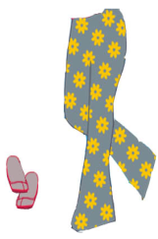 6. 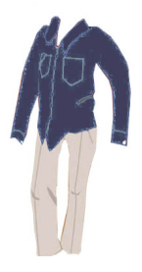 7. 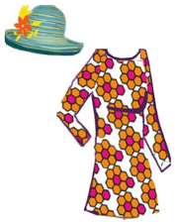
denim shirt - beige chinos - baggy shorts - a beautiful floral dress - jogging bottoms - striped t-shirt - colourful cardigan - flared trousers - dark blue denim shirt - summer hat - sandals - deck shoes - trainers - trousers with floral pattern
PICTURE 1: ………………………………………………………………… …………………………………………………………
PICTURE 2: ………………………………………………………………… …………………………………………………………
PICTURE 3: ………………………………………………………………… …………………………………………………………
PICTURE 4: ………………………………………………………………… …………………………………………………………
PICTURE 5: ………………………………………………………………… …………………………………………………………
PICTURE 6: ………………………………………………………………… …………………………………………………………
PICTURE 7: ………………………………………………………………… …………………………………………………………

LISTENING:
PART ONE: LISTEN TO THE RADIO PROGRAM TWICE (FIRST WITH THE TEXTS AND THEN WITHOUT THEM). FILL IN THE GAPS AND THEN DRAG THE WORDS TO THE CORRECT GAPS.
WRITE DOWN YOUR SCORES:
Right answers | Wrong answers | Total items
 |  | ....... / 12
 |  | ....... / 7
PART TWO:
WHAT DO THESE ICONS MEAN?
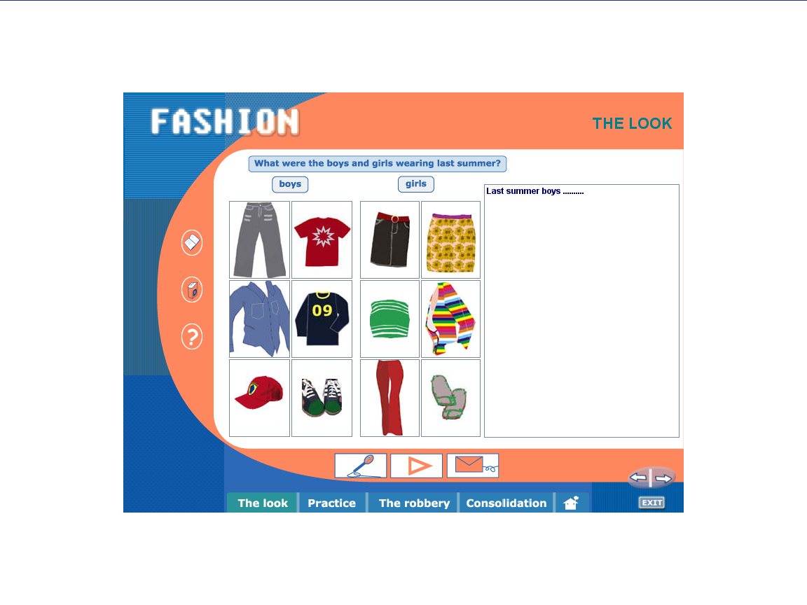
- ______________________________________________
- ______________________________________________
- ______________________________________________
WITH THE HELP OF THE PICTURES, WRITE ABOUT LAST YEAR´S FASHION. Record it and then send it to the teacher: mtolsec@yahoo.es
PRACTICE
GRAMMAR
PAST CONTINUOUS: STUDY THE GRAMMAR EXPLANATION WITH THE HELP OF THIS ICON 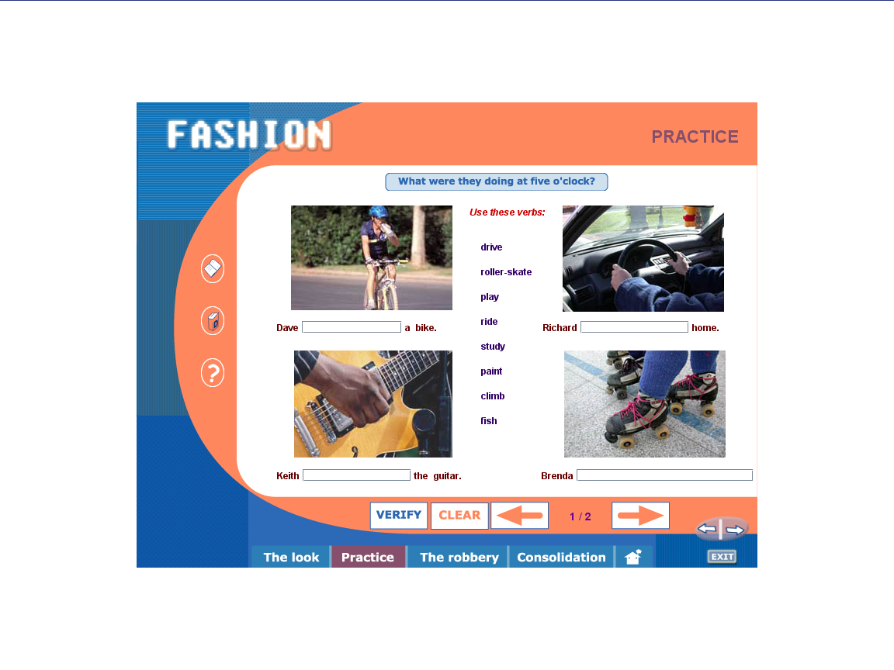 THEN DO THE EXERCISE.
WHEN YOU FINISH, WRITE DOWN YOUR SCORE:
Right answers | Wrong answers | Total items
 |  | ....... / 8

REVISE THE IRREGULAR VERBS AND YOU WILL SEE THIS PICTURE: 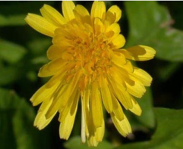. WHILE YOU DO IT, FILL IN THIS CHART WITH THE 9 HIDDEN VERBS:
BASE FORM | PAST SIMPLE | MEANING
WHILE / WHEN: STUDY THE USE OF THESE CONNECTORS WITH THE HELP OF THIS ICON AND PUT THE WORD IN THE CORRECT ORDER. HAVE YOU MADE ANY MISTAKE? IF SO, COPY THE SENTENCE/S:
……………………………………………………………………………………………………………………………………………………………………………………………………………………………………………………………………………………………………………………………………………………………………………………………………………………………………………………..
WRITE DOWN YOUR SCORE:
Right answers | Wrong answers | Total items
 |  | ....... / 6

THE ROBBERY
LISTENING: (WHAT DOES THIS ICON MEAN 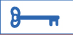? …………………………………………………………….).
WHICH IS THE CORRECT PICTURE 1, 2, 3 OR 5? ……… WHY? ……………………………………………………
………………………………………………………………………………………………………………………………………………….
MATCH THE TWO HALVES OF THE SENTENCES AND THEN WRITE DOWN YOUR SCORE:
Right answers | Wrong answers | Total items
 |  | ....... / 8

COPY ONE SENTENCE WITH WHEN AND ANOTHER ONE WITH WHILE:
……………………………………………………………………………………………………………………………………………………………………………………………………………………………………………………………………………………………………
COMPLETE THE SENTENCES AND THE INTERVIEW. DID YOU MAKE ANY MISTAKE? IF SO WRITE THEM HERE:

CONSOLIDATION

THEN WRITE DOWN YOUR SCORE (ONE POINT FOR EACH CORRECT GAP):
Right answers | Wrong answers | Total items
 |  | ....... / 16
 |  | ........ / 14

CONSOLIDATION
PHONETICS
STUDY THE DIFFERENCE BETWEEN THESE TWO SOUNDS 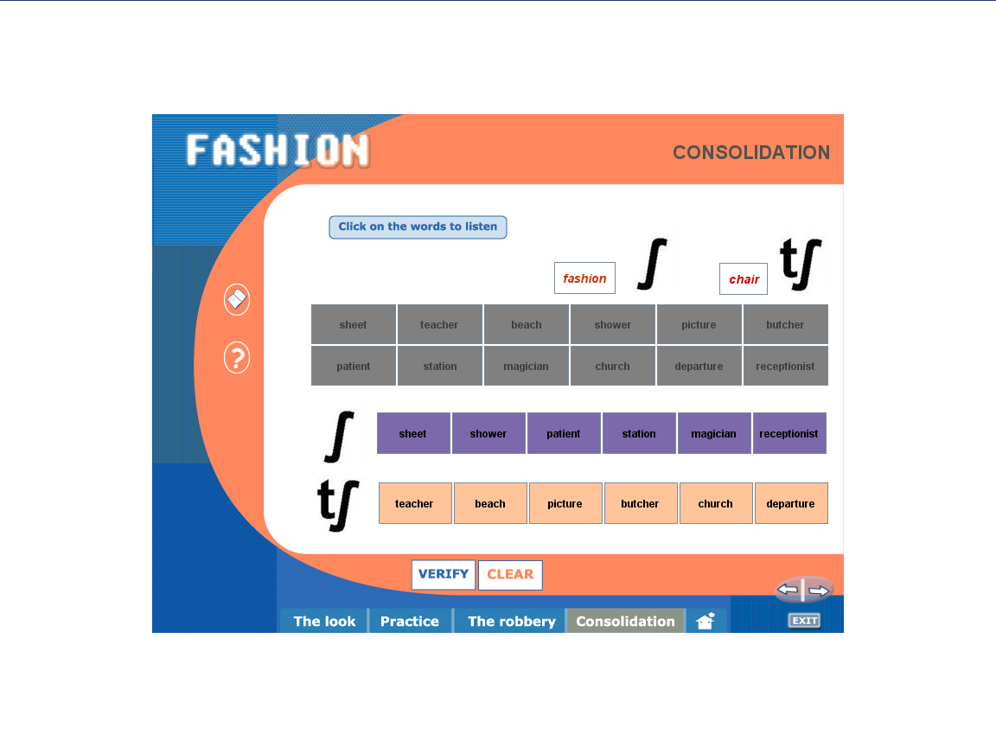WITH THE HELP OF THIS ICON . LISTEN CAREFULLY TO THE EXAMPLES GIVEN AND THEN DO THE EXERCISE. CAN YOU THINK OF TWO MORE WORDS WITH THESE SOUNDS?
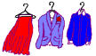
: _____________ ______________
: _____________ ______________
READING COMPREHENSION: WRITE THE NAMES AND THEN WRITE DOWN YOUR SCORE
Right answers | Wrong answers | Total items
 |  | ....... / 5

COMPOSITION: CHOOSE ONE OF THE GIRLS TO DESCRIBE WHAT SHE IS LIKE AND WHAT SHE IS WEARING:

CROSSWORD. WRITE YOUR OWN CLUES FOR OTHER TWO ITEMS OF CLOTHING:
- _______________________________________________: ______________

- _______________________________________________: ______________
READING COMPREHENSION: READ THE TEXT AND DO THE ACTIVITY. THEN ANSWER THE QUESTIONS:
- What is “fashion”?

- Who dictates fashion?

- Why is fashion in continuous change?

- In high schools, what are the names of groups according to their styles?

- Do you agree with the statement “Styles show who you are, but they also create stereotypes and distance among groups”? Why or why not?

EXTRA ACTIVITIES
CLOTHES Study these words

Men's Clothes
 |  | 
suit(s) | shirt(s) | tie(s)

Women's Clothes
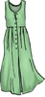 | 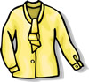 | 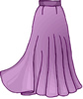
dress(es) | blouse(s) | skirt(s)
 | 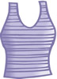
 | tanktop(s)

Uni-Sex
 | 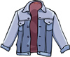 | 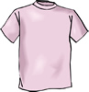
coat(s) | jacket(s) | t-shirt(s)
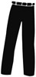 | 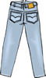 | 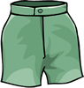
trouser(s) | jean(s) | short(s)
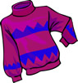 | 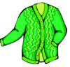 | 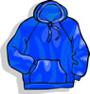
jumper(s) pullover(s) | cardigan(s) | sweatshirt(s)

Baby Clothes
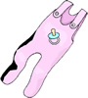 | 
romper suit(s) | nappy (nappies)

Holiday/Leisure Clothes
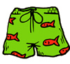 | 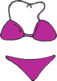 | 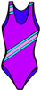
swimming trunk(s) | bikini(s) | swimsuit(s)  swimming costume(s)  bathing costume(s)

Nightwear
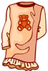 | 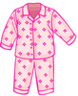 | 
nightdress(es)  nightie(s) | pyjama(s) | dressing gown(s)

Underwear

Mens
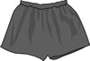 | 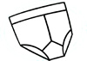
boxers | y-fronts vest

Ladies (Lingerie)
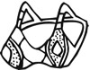 | 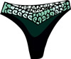
bra(s) | pant(s)  knicker(s)
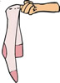 | 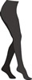
stocking(s) | tight(s)

Footwear
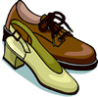 | 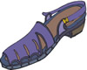 | 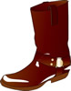
shoe(s) | sandal(s) | boot(s)
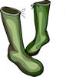 |  | 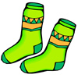
wellington(s) | slipper(s) | sock(s)

Accessories 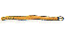belt(s)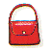 handbag(s)
headscarf (headscarves) 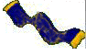scarf (scarves)
glasses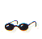 sunglasses 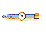watch(es)
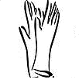glove(s) hat(s)
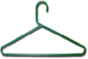hanger(s)

Jewellery bracelet(s)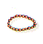 necklace(s)
ring(s) 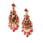earring(s)

Parts of clothes
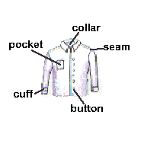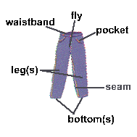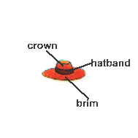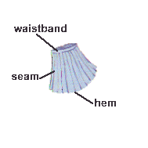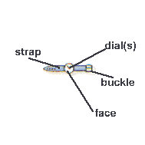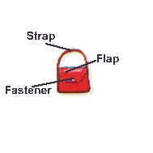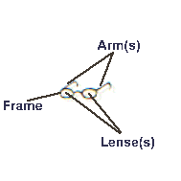

EXERCISES
1 Based on the vocabulary, do the following activities (Ctrl + Click)
http://www.learnenglish.de/Games/Crossword4/Clothes.htm
http://www.learnenglish.de/Games/MatchIt/MatchItClothes.htm

2 In pairs, do the following Webquest “Fashion is a passion”:
http://www.vandelvira.net/phpwebquest/webquest/soporte_horizontal_w.php?id_actividad=639&id_pagina=5

