Name: ____________________________________________ Number: _______ Group: 3º A
READING (16 points)
1 Read the text.
1960s Fashion 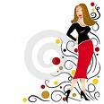
My grandmother was still a young woman in the 1960s, and she’s got some amazing photos from that time. In one photo she was wearing an incredibly short pink plastic miniskirt with a little white top and white boots. In another one she was wearing a bright red trouser suit – that was a pair of trousers and a jacket that went together. When she bought this in the early 1960s, it still wasn’t usual for women to wear trousers when they went out, and in one restaurant the manager told her to leave. Later she had some white ‘hot pants’ which were very short shorts. She always put on a lot of make-up, especially around her eyes.
My grandfather also wore bright clothes – he had lots of flowery shirts. In 1968 he bought some green flares which were very wide at the bottom – they were called ‘bell bottoms’ when they first appeared. And he had a favourite green cap that he wore for a few years.
I think 1960s fashions look a bit silly – but my grandparents say it was a good time to be young.
1 Complete the table. (6 x 2 = 12)
1960s name | Type of clothes | Colour
miniskirt  (2) ________  bell bottoms  hot pants | skirt  trousers & jacket  (4) ________  (5) ________ | (1) ________  (3) ________  green  (6) ________
2 Answer the questions. (2 x 2 = 4 points)
1 What did the woman wear on her face?

Name: ………………………….. Mark: …………
2 What did the man wear on his head?

VOCABULARY (20 points)
- Choose two items for each picture (7 x 2 = 14 points)
b
d
d
b
f
f
h
h
a
a
c
c
e
e
g
g
j
h
e
i
k
1.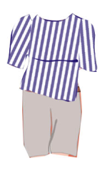 2.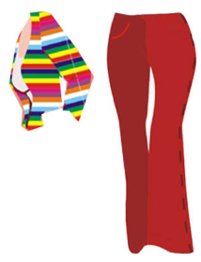 3. 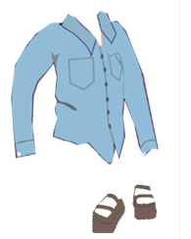 4. 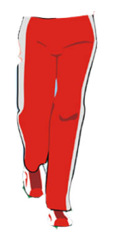

5. 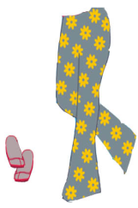 6. 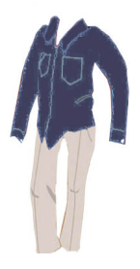 7. 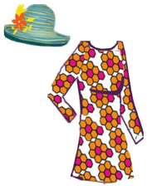

denim shirt - beige chinos - baggy shorts - a beautiful floral dress - jogging bottoms - striped t-shirt - colourful cardigan - flared trousers - dark blue denim shirt - summer hat - sandals - deck shoes - trainers - trousers with floral pattern

PICTURE 1
PICTURE 2
PICTURE 3
PICTURE 4
PICTURE 5
PICTURE 6
PICTURE 7

2 Circle the correct answers. (6 x 1 = 6 points)

Name: ………………………….. Mark: …………
1
2
3
4
5
6
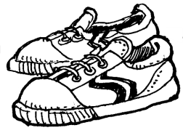 | 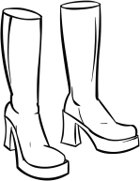 | 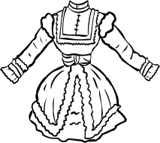
a. hot  b. practical | a. trendy  b. comfortable | a. fashionable  b. outdated
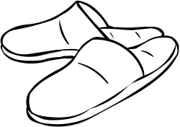 | 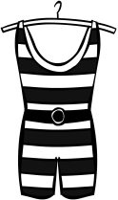 | 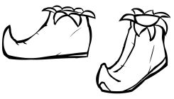
a. latest  b. comfortable | a. old-fashioned  b. modern | a. unusual  b. practical

GRAMMAR (24 points)
1 Complete the paragraph below with the verbs in brackets. Use the Past Simple or the Past Continuous. (10 x 1 = 10 points)
At 1.00 in the afternoon, my friend and I ¹ ………………………… (walk) on Main Street when suddenly we ² ………………………… (see) a policeman. He ³ ………………………… (chase) a short man with a black hat and gloves. “Stop that robber!” the policeman ⁴ ………………………… (shout). The short man with the hat and gloves ⁵ ………………………… (run) towards us and he ⁶ ………………………… (carry) a big brown bag. I ⁷ ………………………… (not have) any time to think. I ⁸ ………………………… (jump) onto the robber and he ⁹ ………………………… (fall) to the ground. The policeman ¹⁰ ………………………… (catch) him and said to me, “Thanks, you were great!”
2Classify these words according to how they are pronounced. (14 x 1 = 14 points)

teacher - fashion - chair - sheet - beach – departure - magician
station – picture - shower - butcher - receptionist – patient - church
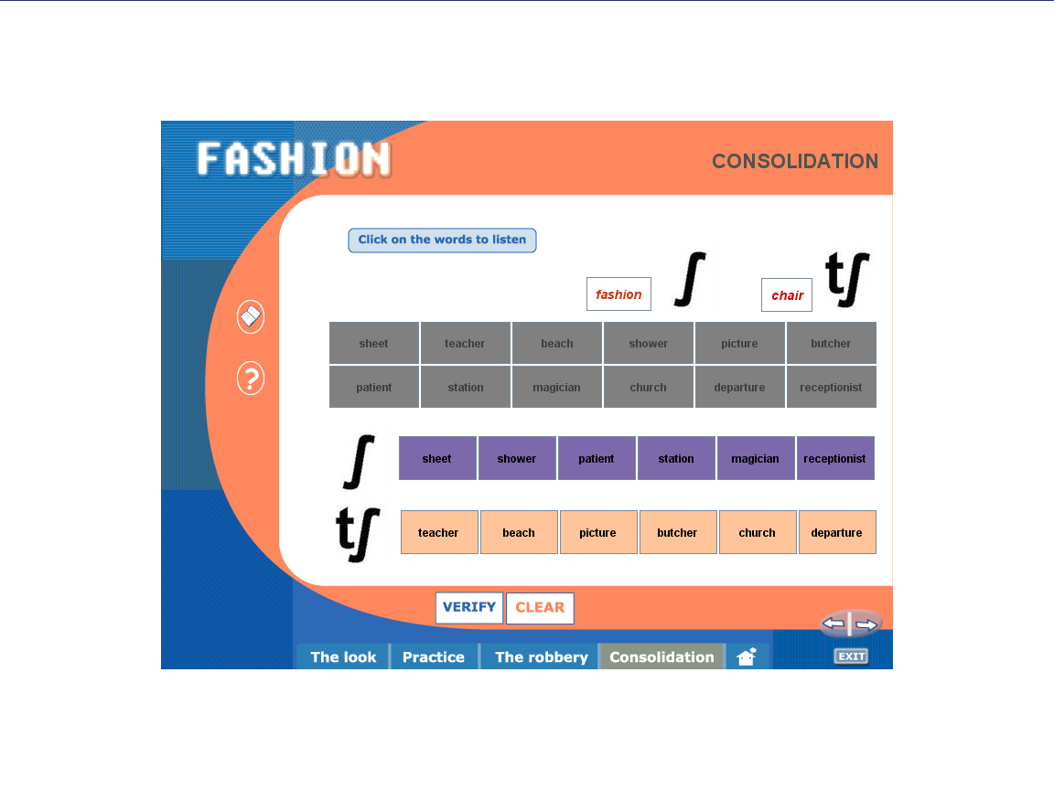

WRITING (10 points)
- Describe what these girls were wearing yesterday.

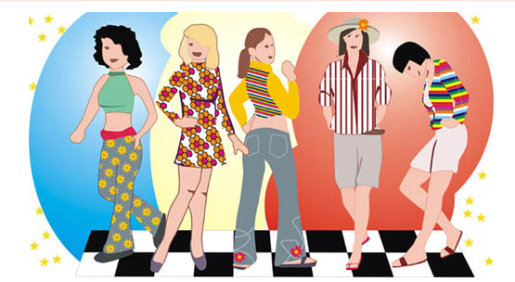
Sally Norma Linda Gwen Patty

LISTENING  (10 points)
Listen and label the girls: Tina, Dawn, Sarah, Lucy and Jen.
5.
1.
2.
3.
4.

SPEAKING (10 points)
For the teacher:
1. Tell the students to work in pairs. Give each student half of this page.
2. Tell the students to take turns asking and answering questions to complete the charts.

Student A
1 Ask your partner questions to find out what the people were doing at 10 o’clock last night. Then tick () the answers in the chart.
 | having dinner | working | reading a book | watching TV | talking on the phone
optician
soldier
judge
detective
dentist
Was the optician having dinner?
2 Answer your partner’s questions about the people below.
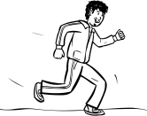 |  | 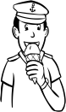 |  | 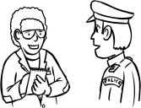 |  | 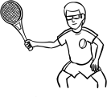 |  | 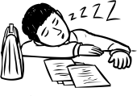
hairdresser |  | sailor |  | reporter |  | spy |  | lawyer

Student B
1 Answer your partner’s questions about the people below.
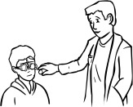 |  | 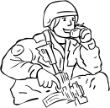 |  | 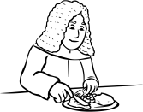 |  | 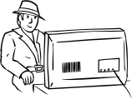 |  | 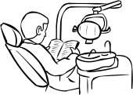
optician |  | soldier |  | judge |  | detective |  | dentist
2 Ask your partner questions to find out what the people were doing at 10 o’clock last night. Then tick () the answers in the chart.
 | sleeping | talking to the police | jogging | eating an ice cream | playing tennis
hairdresser
sailor
reporter
spy
lawyer
Was the hairdresser playing tennis?

