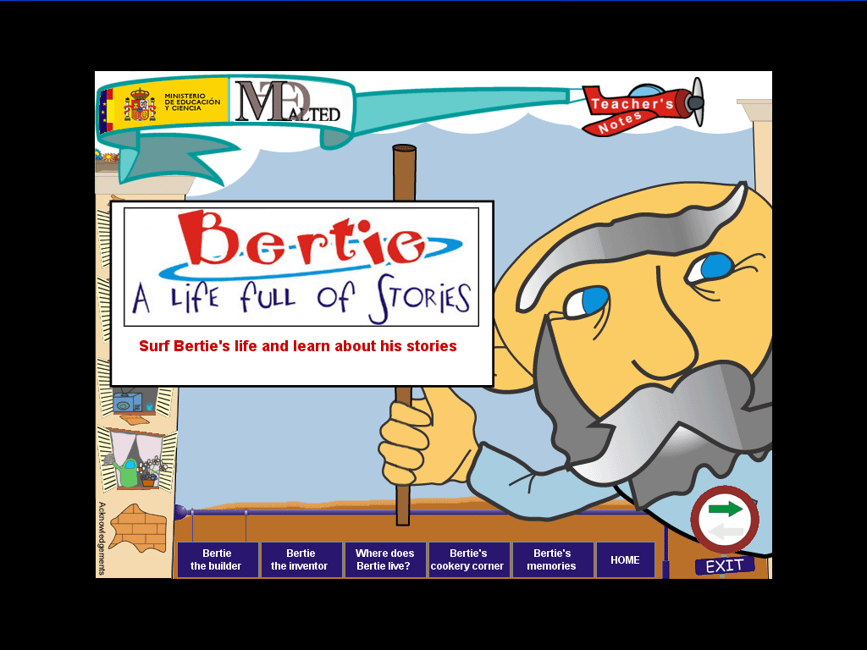

Unit Plan
Grammar | The passive voice  By+ agent
Vocabulary | Cooking and recipes (revision)  Inventions and machines  Mobile phones  Verbs and prepositions
Functions | Describing processes and changes  Understanding technical instructions
Phonetics | < -ed > endings
Writing | For and against essay
Material required:
Personal Computer
Earphones
DVD unit: Bertie (unit 9 for 4º ESO)
Workbook (pages 44-49; page 81)
Remember:
Before you start doing the activities on your computer, read the instructions carefully.
Use the help sections on the left side of the screen.
Read the Grammar explanations on “Resources” and if you don’t understand them, go to Grammar Appendix, Unit 7 in your workbook.

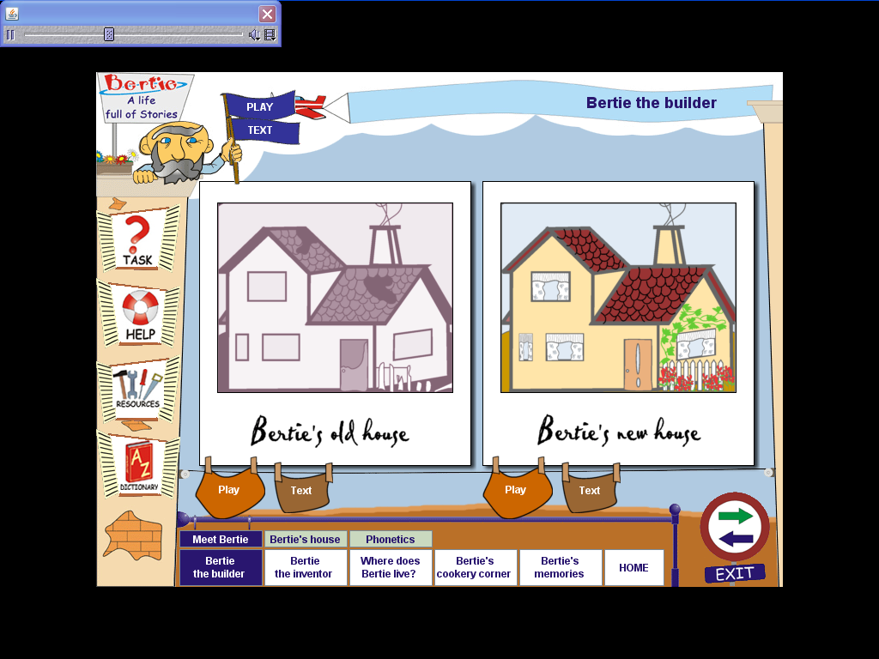

Part 1 Bertie the builder  Listening activity |  | Tick () when done
Task 1 | Meet Bertie ( listening comprehension)
Task 2 | Bertie’s house ( listen and fill in the gaps)
Task 3 | Phonetics ( listen and drag the right answers)
Workbook
Writing activity
Page 44 | Exercises 1-3 (Vocabulary on mobile phones)
Page 45 | Exercises 4-5 (Vocabulary on mobile phones)

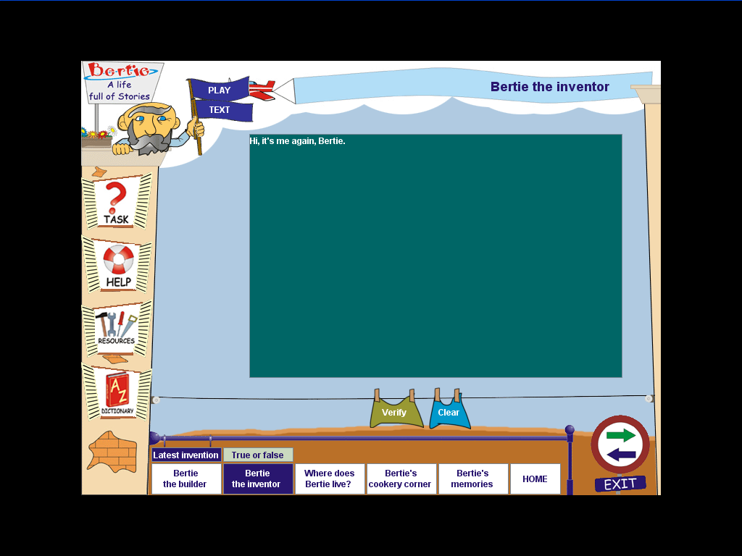

Part 2 Bertie the inventor  Listening activity |  | Tick () when done
Task 1 | Latest invention (listen and write) Dictation
Task 2 | True/false (listening comprehension)
Workbook
Reading comprehension activity
Page 48 | Exercises 2 and 3

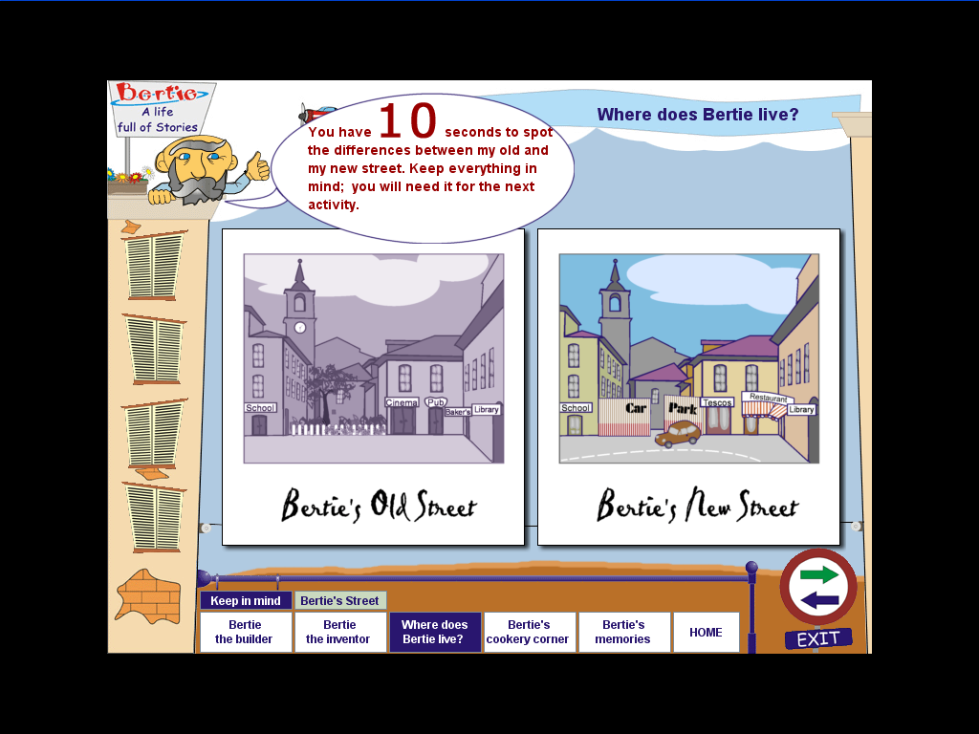

Part 3 Where does Bertie Live? |  | Tick () when done
Task 1 | Keep in mind
Task 2 | Bertie’s street ( listen and drag the verbs to their right place)
Workbook
Grammar
Page 46 | Exercises 1-2-3 and 4

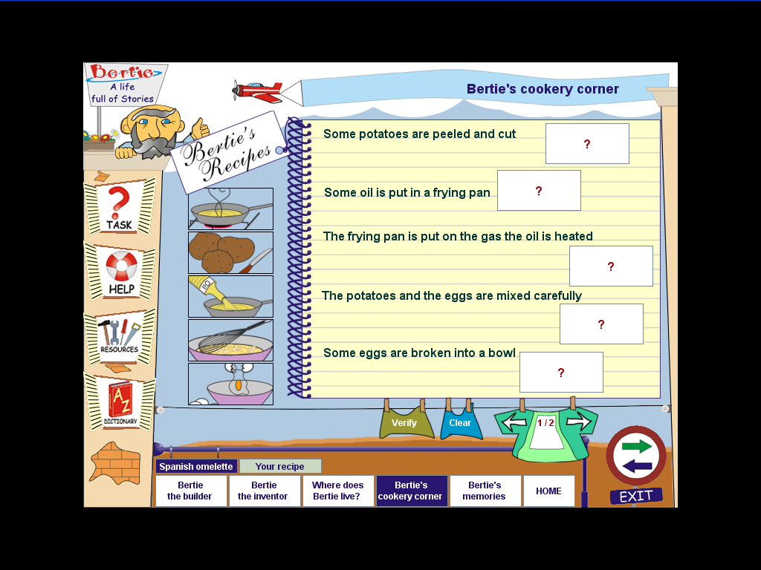

Part 4 Bertie’s cookery corner |  | Tick () when done
Task 1 | Spanish omelette (Reading comprehension)
Task 2 | Your recipe ( writing and printing)
Workbook
Grammar
Page 46 on | Exercises 5-6-7

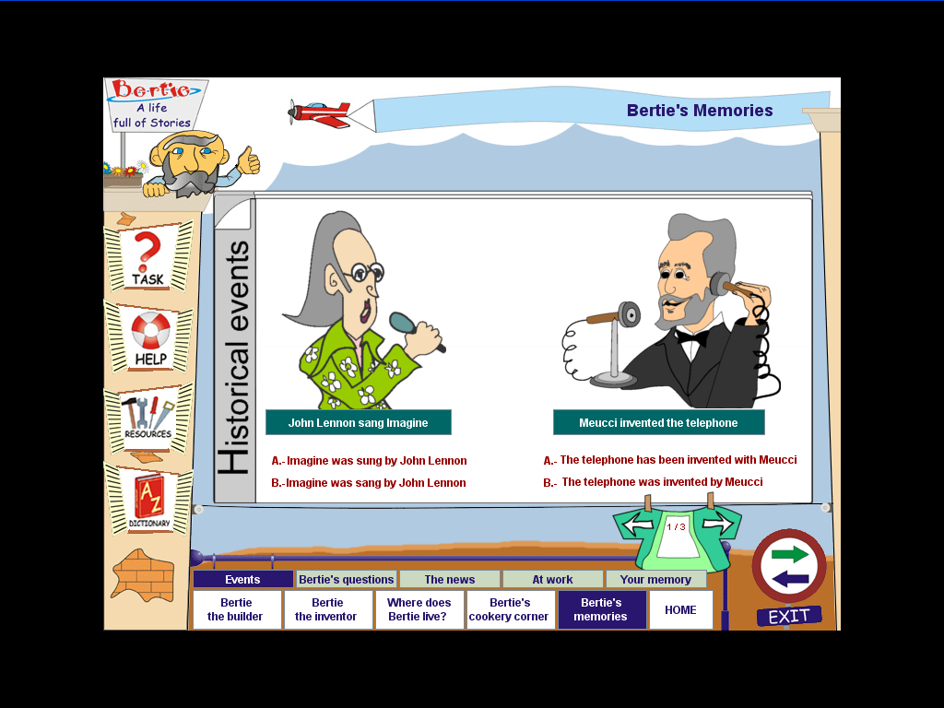

Part 5 Bertie’s memories |  | Tick () when done
Task 1 | Events (choose the appropriate sentence)
Task 2 | Bertie’s questions (complete the sentences)
Task 3 | The news ( listen and write)
Task 4 | At work (read and drag)
Task 5 | Your memory (match pairs)
Workbook
Writing
Page 49 | Exercise 1
Page 81 | Writing: brainstorming and first draft

