Unit 2 Test from Malted: Neighbours

I Series
Write four sentences using present progressive: look at the picture to describe what the people are doing.


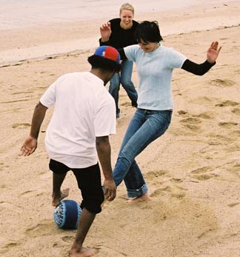

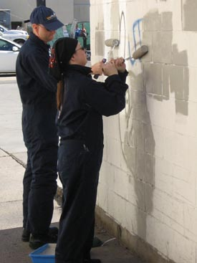

- ___________________________________________________

2._____________________________________________________

3._____________________________________________________

4._____________________________________________________

II series

Write the names of the following pictures



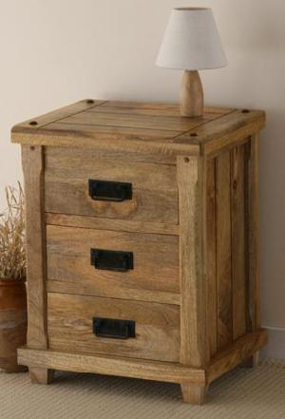

__________________ ____________________ ______________

III series
Write a description from the information given below

José’s Diary
What is he doing today?

Today is February 27th
Study math and philosophy
Play tennis
Birthday party
Parent’s anniversary

______________________________________________________

______________________________________________________

______________________________________________________

IV series

Change the following sentences form present progressive into negative and interrogative forms.

- Andrew is painting his room.

__________________________________________

- Anna is running fast.

__________________________________________

- Roberto is studying English.

__________________________________________

- They are decorating their room.

__________________________________________

- I am eating meat.

__________________________________________

6. Alice is making dinner right now.
__________________________________________

V Add “ing” ending to the following words.

- cry____________ 2. lie______________ 3.study__________

4. play___________ 5. stay______________6. try___________

7.carry____________8. reply_____________9. marry________

Series VI. Answer the following questions:

1. Is John reading a book? _______________________________

2. What are you doing? __________________________________

3. Is Silvia listening to music? _____________________________

4. How many students are in your classroom? _____________________________________________________

5. Is Maria sitting next to Paul? ____________________________

6. Is the phone ringing? _________________________________

7. Are Carlos and José playing tennis now?

_____________________________________________________

Series VII
Use the words below to make sentences in present progressive.

1. I / to read a book _____________________________________

2. it / to rain ___________________________________________

3. he / to repair his bike_________________________________

4. they / to watch a film __________________________________

5. the cat /to sleep on the chair ___________________________

6. Jane and Emily / to do their homework ___________________

7. Bill / to wait at the bus stop ____________________________

8. we / to listen to the radio ______________________________

9. the children / to play a game ___________________________

10. Laura / to walk the dog _______________________________

