Unit 1 test for Malted: My New School

Series I. Answer the following questions orally:

- What´s your name? _______________________________

- How old are You? ________________________________

- Where do you study? _____________________________

Series II. Match the following names with their descriptions:

- Classroom A place where pupils practice sports

- Laboratory A place equipped for science experiments

- Gym A place pupils investigate and read

- Library A place where teachers gather and work

- Staffroom A place where pupils receive their lessons

Series III Look at the pictures and write their number and name under each picture.

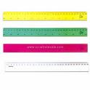
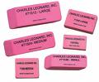
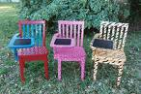
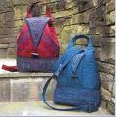

Series IV Unscramble the following sentences:

- Luis name Hi, is my _________________________________________

- is old twelve he years.

_________________________________________

- favourite my color green is.

_________________________________________

- got two I have sisters.

_________________________________________

- food is My beef favorite.

_________________________________________

- number My lucky twenty is.
_________________________________________

- Old are How you?

_________________________________________

- You do where live?

_________________________________________

Series V. Read the following information and then answer the questions below:

She is my friend Elisa. Her favourite subjects are math and science.
She likes to do exercises in the gym. She likes to study and read books.Her favourite food is pizza. She lives in Guatemala. She studies at Principe de Asturias school.



- What’s your friend’s name? ( Elisa) ____________________

- What’s Elisa favourite food? ___________________________

- Where does Elisa live? _______________________________

- Where does Elisa study? _____________________________

- What are Elisa’s favourite subjects? _____________________

- What does Elisa like to do? ___________________________

