Final Assessment for Malted

Name: _________________________________ Section: ____________

Series I Instructions: choose a word to complete the sentences correctly.

- A room in the school where pupils have their lessons.
  - library
  - classroom
  - gym

- A place where pupils practice sports activities
  - library
  - laboratory
  - gym

- A place equipped for the next experimental study of science
  - gym
  - classroom
  - laboratory

- A place where teachers meet
  - gym
  - laboratory
  - staffroom

- Teacher: May I go to the ________ please?
  - school
  - toilet
  - garden

- I am using my ______ to write.
  - eraser
  - bag
  - pencil
- I am using my _______ to carry my books.
  - bag
  - ruler
  - pencil

- I like to eat__________
  - dictionaries
  - apples
  - tables

- My favorite food is____________
  - meat
  - pencils
  - erasers

- Andrew is going to ___________ his room.
  - paint
  - study
  - studies

- I like to play the ___________
  - Dark green
  - Electric guitar
  - book

Final Assessment for Malted

Name: __________________________________ Section: ___________

Series II Instructions: Your teacher dictate you 15 vocabulary words. Write them correctly on the lines provided.

- _____________

- _____________

- _____________

- _____________

- _____________

- _____________

- _____________

- _____________

- _____________

- _____________

- _____________

- _____________

- _____________

- _____________

- _____________

(Words to be dictated by the teacher: paint, bag, gym, laboratory, ice-cream, library, pupil, staffroom, toilet, rubber, wardrobe, neighbour, kitchen, furniture, birthday, bedroom, clothes.)

Final Assessment for Malted

Name: _________________________________ Section: ___________

Series III Instructions: Complete all the sentences with the correct option.

  - What is he doing?
  - He is reading a book.
  - He is reads a book.
  - He is read a book.

  - What are you doing?
  - I am sleeps
  - I sleeping
  - I am sleeping

  - David_____ painting his room.
  - are
  - am
  - is

  - My friend Anne ______ a letter.
  - Is writing
  - Is write
  - Is writes

  - I like to ___________ to music.
  - see
  - listen
  - color

  - Greg and Louis ________ my best friends.
  - is
  - are
  - am

  - Anne ____________ two sisters.
  - have
  - like
  - has

  - ___________ is a teacher.
  - they
  - I
  - He

  - _________ you like ice cream?
  - does
  - do
  - is

  - I _________ getting a poster of my favorite actor.
  - have
  - are
  - am

  - __________ are very close friends.
  - they
  - he
  - she

Final Assessment for Malted

Name: __________________________________ Section: __________

Series IV Instructions: Look at the drawing and answer the following questions


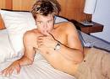

- What is his name?________________________________

- How old is he?___________________________________

- Where is he?____________________________________


What is she doing?

- ____________________________________

Series V Write the vocabulary words

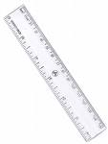

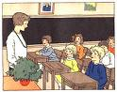
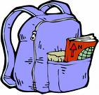

_______________ ___________________ ____________


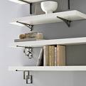
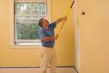

__________________ _______________ ________________

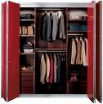
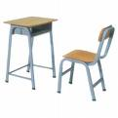
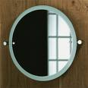

____________________ _____________ ___________
Series VI. Draw pictures of the following words:

- kitchen

- lamp

- to cook

- bedside table

- to hang

- laboratory

- ride a horse

- omelette

- meat

- pen

Series VII Answer the following questions orally:

    - What’s your name?
    - How old are you?
    - Where do you study?
    - What is your favorite food?
    - Where are you from?

