

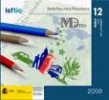

FICHA DE EVALUACIÓN INICIAL/FINAL DEL TEMA
“My school”

Date: ____________________________

Name: ______________________________________ Group 6º A
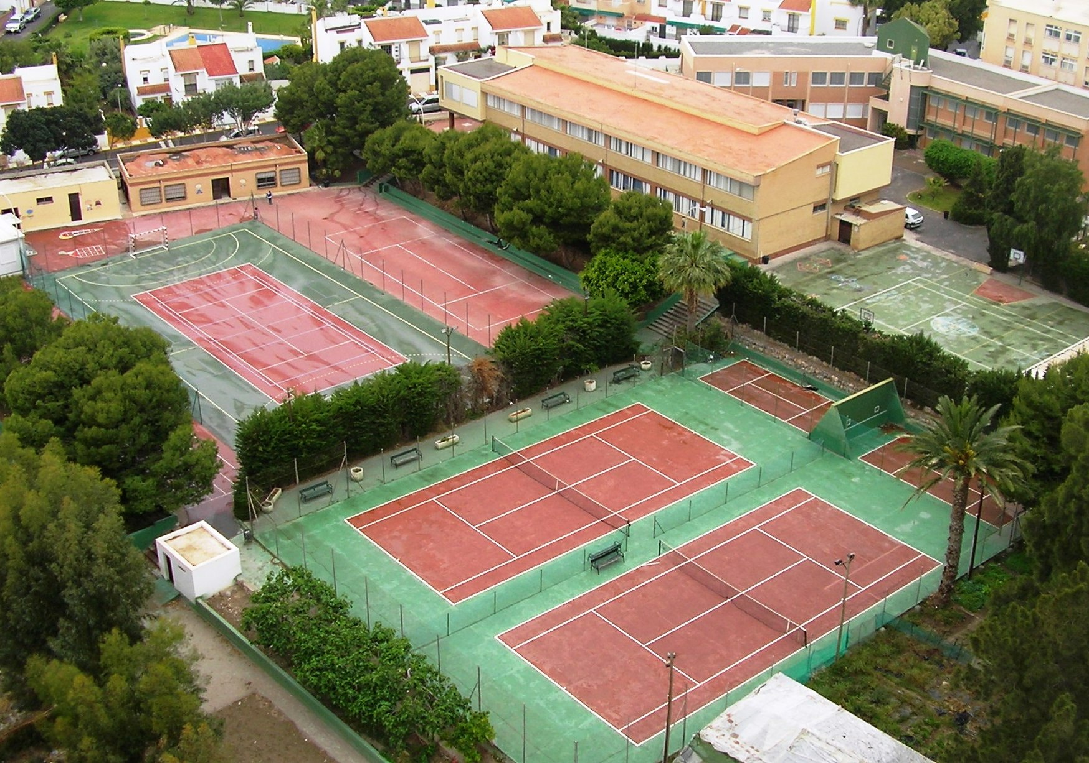
- How old are you? ____________________
- Do you like your school? ______________
- Write the name of six rooms in your school
__________________________________
__________________________________
- Is there a gym in your school? __________________________________
- Write the name of six different things you can find in your classroom.
______________________________________________________________________________________________________________________________________
- Which lessons do you have on Mondays?

9-10,30 _____________________ 10,30-11,30 ____________________
12-13 ______________________ 13 – 14 ________________________

- Write these numbers:
- ___________________________________________________
129 ________________________________________________
806 _________________________________________________
- How many children are there in your classroom? _______________
- Write about you:
Name
Age
Family
Likes
Food
Favourite number

- Listen and write:
- _________________ b) _________________ c) _____________

