WORKSHEET 4

TEACHER: Mº del Carmen Pernas NAME:……………………………
DATE:…………………………….
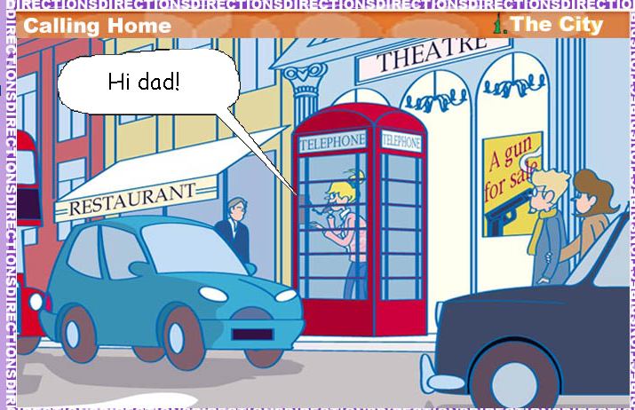

ANSWER:
Where is Julia? What city?

.................................................................................

Who is she talking to?

.................................................................................

Name 3 places that you can find in London

................................................................................................................................................................................................................................................................................................................................................

CLASIFY:
BUILDINGS | ACTIONS | ADJECTIVES

MUSEUM CROWDED SCHOOL
RING THEATRE NOISY
BUSY TRAVEL STAND
GO EXPENSIVE CINEMA

LABEL THE PICTURES:

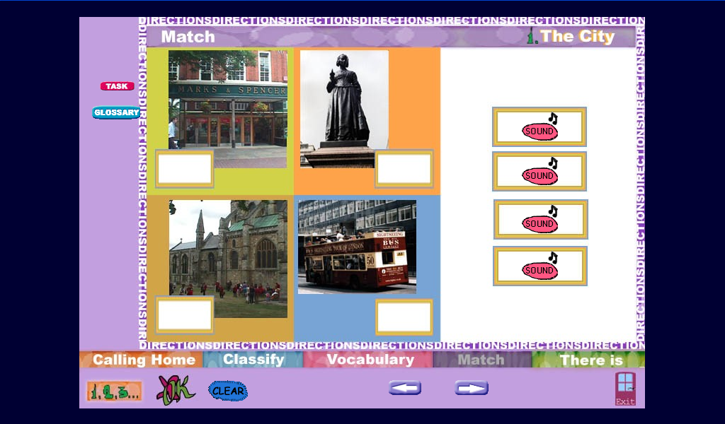

MEANS OF TRANSPORT:
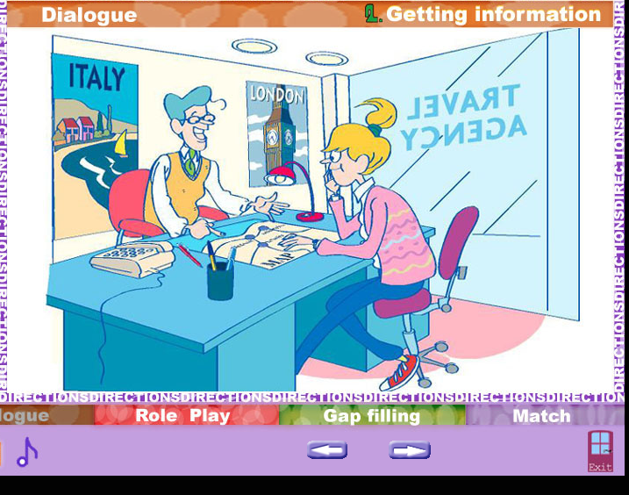

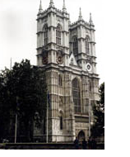

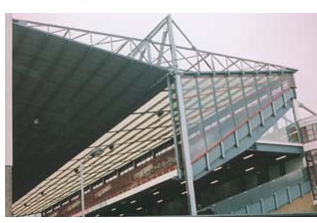
How can you get to How can you get to Westminster Wembley Stadium? Cathedral?

………………………… ……………………………..

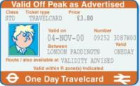
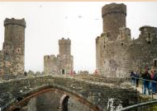
How can you get to How much is the one-day
Windsor Castle? travel card in London?

………………………… ………………………………..

