WORKSHEET 1
Teacher: Mª del Carmen Pernas
NAME:……………………...................………… DATE:……....................…………………………

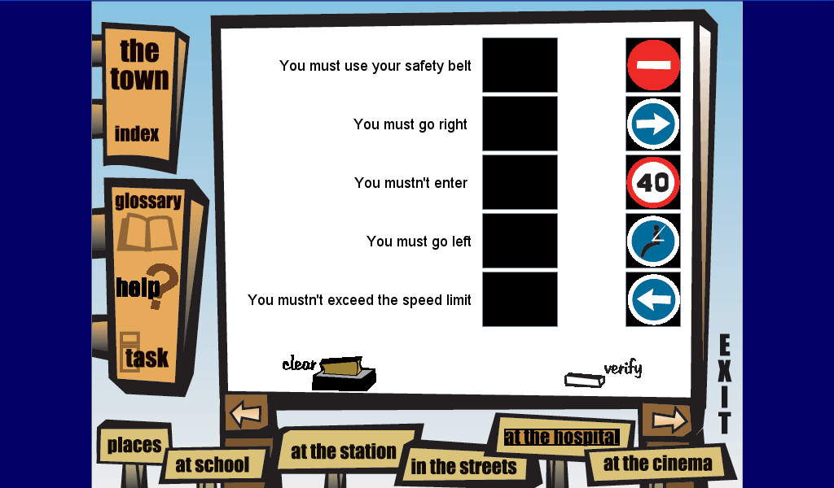
Complete with: must / musn’t and match

You ____________use your safety belt

You ____________ go right

You _____________enter

You ____________ exceed the speed limit

You ____________ go left

Draw the signs:

You musn’t park here You must be quiet

