WORKSHEET 1
Teacher: Mª del Carmen Pernas
NAME:………………………………
DATE:………………………………
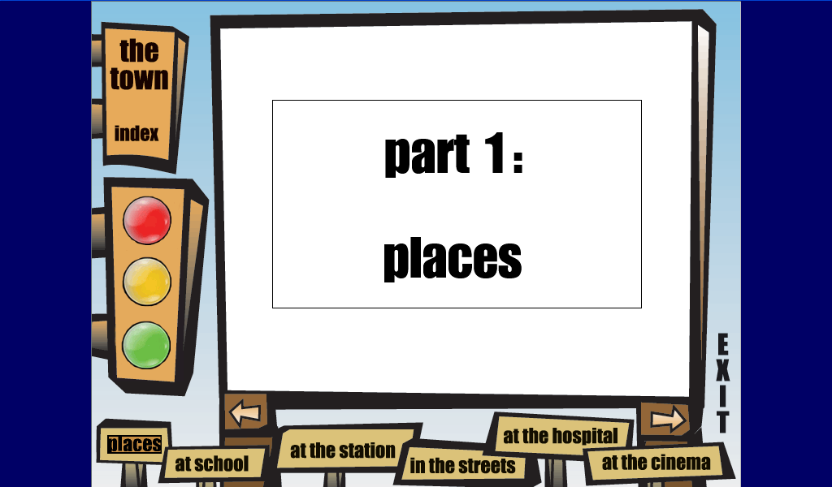
What places can you see here?...................................................................................................................................................................................................................................................................................................
Which of them can you find in your town?
....................................................................................................................................................................................................................................................................................

Name 4 places that you can see in the picture

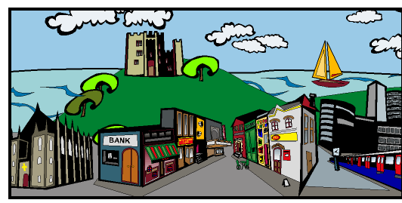
.........................................................................................................................................................................................................................................................................................................................................................
Who is speaking in the text?....................................................

Is the town by the sea?.....................................................

Label the pictures:
