FINAL TEST
NAME:……………………………………………………………DATE:……………….............

Name 10 places in a town:

....................................................................................................................................................................

....................................................................................................................................................................

Write 5 school rules:

....................................................................... ............................................................................

....................................................................... ............................................................................

.......................................................................

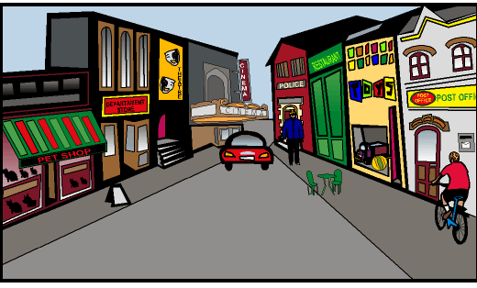
Write at least 4 sentences to describe the picture using: between, behind, next to, oppossite:

.......................................................................................

.......................................................................................

.......................................................................................

.......................................................................................

.......................................................................................

Write the signs meaning using MUST / MUSN’T

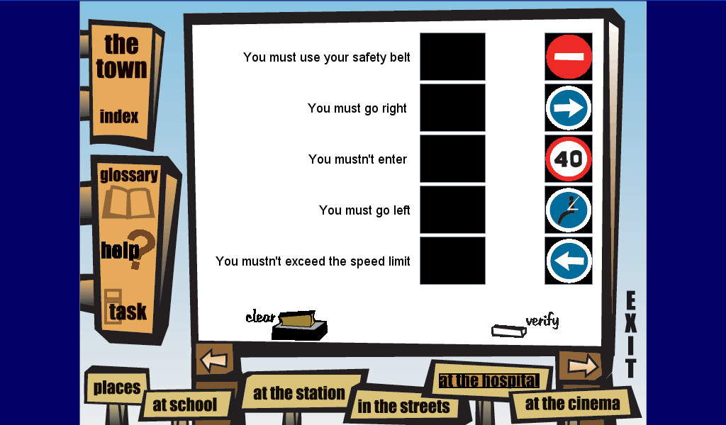

.................................................................................................

..................................................................................................

..................................................................................................

..................................................................................................

Write the names:

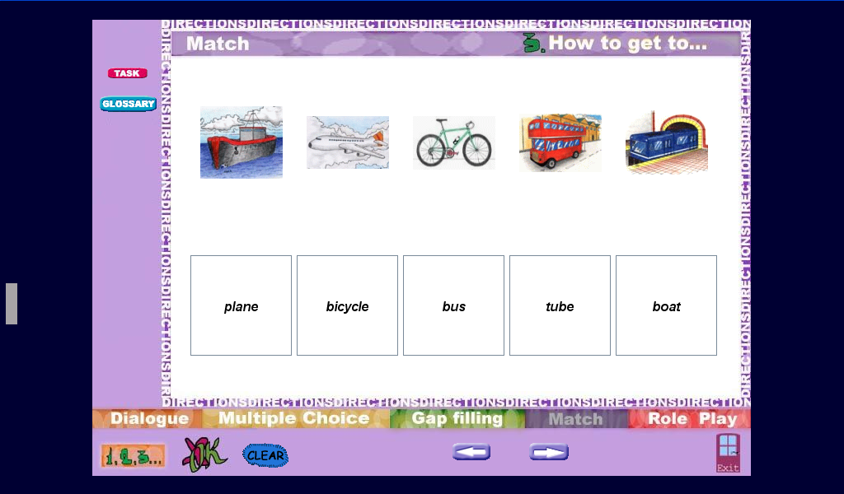

............................. .............................. .............................. ............................ ..........................

Write an e mail to your new friend in London who in going to visit you this summer, describing your town:
From:
To: John

