WORKSHEET: THE WEATHER FORECAST
NAME: ______________________________________________________________________

PART 1: THE WEATHER
Write the correct name under each picture
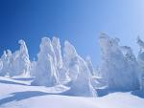 | 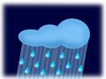 |  | 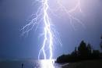 | 

PART 2: THE HOLIDAY WEATHER 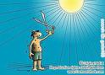
Classify the following words into adjectives, nouns or adverbs:
Rain, strongly, cold, cloudy, quickly, hot, foggy, heavy, humidly, snow, heavy, hail, lightning, lightly, storm, sleet, terribly, happily
ADJECTIVES | NOUNS | ADVERBS

PART 3: THE WEATHER FORECAST 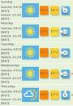
What’s the weather like in Great Britain? Use the information of the activity.
PART 4: MY WEATHER REPORT 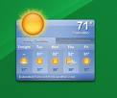
What would you say in the following situations?
- Your friend is ill.
- Your class will have a test tomorrow.
- Your little sister is playing with matches
- You see a car accident

