TRADITIONS TEST
NAME : ______________________________________________________________________
- Answer the following questions
Guy Fawkes night is a huge UK tradition, probably bigger than Halloween. Traditionally it is taught that Guy Fawkes plotted to blow up The Houses of Parliament with explosives but various myths are debunked in the sites below which give a mixture of the myths and the reality.  1. Why did Guy adopt the name Guido?  2. Which famous building did he want to blow up?  3. Who was King James’ mother?  4. Is 5th November a public holiday?  5. Was Guy Fawkes tortured?  6. When and where was Guy Fawkes born?  7. Is Bonfire Night only celebrated in Britain? Where else is it still celebrated? |  | 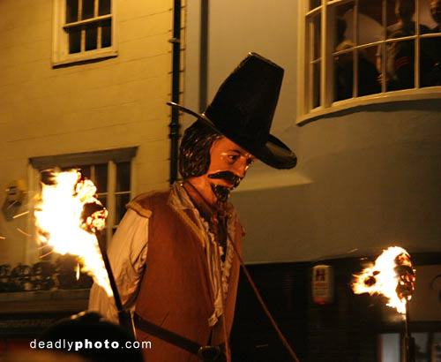

Christmas Vocabulary. Gap-Fill Exercise
carols chimney Christmas Eve eggnog mass mistletoe ornaments reindeer sleigh stockings

Susan : Merry Christmas, come on in and take off your coat - it's cold out there.
Stephan : Merry Christmas. Let me take off my boots, I don't want to get snow all over the place.
Susan : Would you like some __________ ? It's a traditional Christmas drink made with milk, eggs, vanilla and rum.
Stephan : That sounds delicious! I'd love some.
Susan : So, are you ready to decorate the tree? The kids are in the living room right now unpacking the __________ and preparing the lights... Oh, Stephan, you're standing under the __________! You have to give me a kiss.
Stephan : That's a nice Christmas tradition. I brought you a little gift. It's a CD of traditional Christmas __________ from my country. I hope you like it.
Susan : Oh, how wonderful, let's put it on right now while we are decorating the tree.
Stephan : I don't really know much about Christmas in America. How do you celebrate it here?
Susan : Well, usually the family gets together on __________ and has a nice dinner. Some people go to midnight __________, others stay at home and celebrate with their families and friends. Some people open a gift or two, but my family is very traditional. We wait until Christmas morning to open the gifts from Santa.
Stephan : I have heard American children talking about Santa Claus. How do you describe him in the States?
Susan : In America, we have a very set picture of Santa Claus. He dresses in red and white clothes and travels in a magic __________ pulled by flying __________.He enters your house by climbing down the __________ and he leaves gifts under the Christmas tree and in __________ which we hang above the fire place.


Questions about Christmas 2009 - 2010

- Where have you been at Christmas?
- How often did you see your friends last Christmas?
- How much have you spent at Christmas?
- Did you receive any presents?
- How many and which presents did you receive?
- What did you wear on New Year’s Eve?
- Did you go to the disco?
- How long did you stay at the disco on New Year’s Eve?
- How far is the disco from your house?
- What time did you get home on New Year’s Eve?
- Did you attend any religious celebrations?
- Did you do any homework?
- Did you spend much time with your family?
- Did any special things happen to you?
- Did you meet any new friends? Where and when did you meet them?

Rewrite the following sentences in Present Simple Passive voice.
- Santa opens the door.
- We set our Christmas table.
- She pays a lot of money for her Christmas presents.
- Santa wears a red suit.
- He doesn’t open his presents.
- You don’t write Christmas cards.


