MALTED UNITS TEST
NAME : ______________________________________________________________________
- Complete the text with the right word.
- Daphne was ___________, daughter of the river god ___________. The god Apollo ___________ ___________, but she ___________ his advances. When Apollo advanced upon her she was changed into a ___________ ___________
- Pope John was born in ___________ and ___________ in love with Benedictine monk. She was a legendary ___________ occupant of the papal throne.
2) Write the name of each character
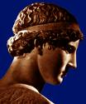
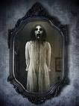
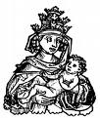
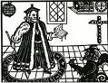
REMEMBER!


- Write the sentences with the verbs in brackets. Use the Present Perfect Simple or Past Simple.
- Jane (stay) ___________ at home yesterday.
- Your letter (arrive) ___________ two days ago.
- I (live) ___________ here for ten years.
- Last week we (go) ___________ to the cinema.
- The game (start) ___________. They are playing now.
- I (phone) ___________ you at five and you weren’t there.
- I (lose) ___________ my watch, I can´t find it.
- Last month Sarah (travel) ___________ to Italy.
- I (work) ___________ all day and now I’m tired.
- We (buy) ___________ a new house last week.

- Choose the correct ending sound for the verbs in the simple past.
- Liked
- /d/
- /t/
- /id/
- Wanted
- /d/
- /t/
- /id/
- Lived
- /d/
- /t/
- /id/
- Finished
- /d/
- /t/
- /id/

- Put the verbs into the correct tense (Simple Past or Past Progressive).
- While Tom (read) ___________, Amely (watch) ___________ a documentary on TV.
- Marvin (come) ___________ home, (switch) ___________ on the computer and (check) ___________ his e-mails.
- Nobody (listen) ___________ while the teacher (explain) ___________ the tenses.
- While we (do) ___________ a sight-seeing tour, our friends (lie) ___________ on the beach.
- He (wake) ___________ up and (look) ___________ at his watch.

