NAME: _________________________________________________________________________________
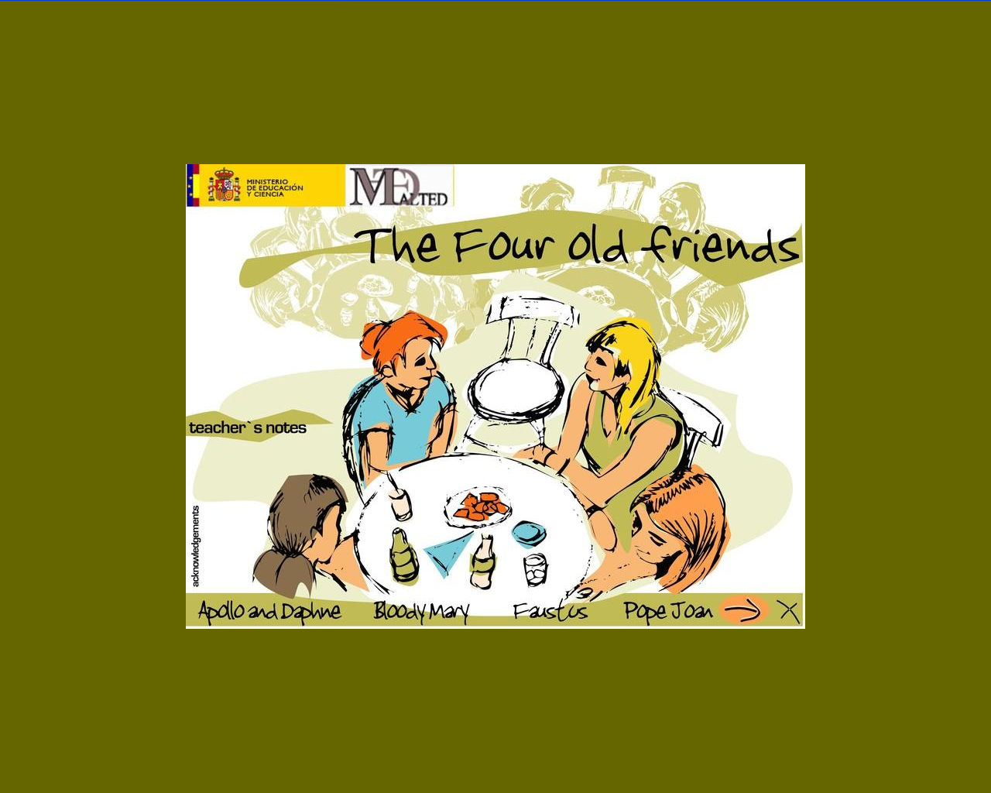
NEW VOCABULARY:

GRAMMAR:

GRAMMAR:
THINGS I LIKE: | 

THINGS I DON’T LIKE:

DATE | CONTENTS | SKILLS | SCORE | PROBLEMS

NAME: _________________________________________________________________________________
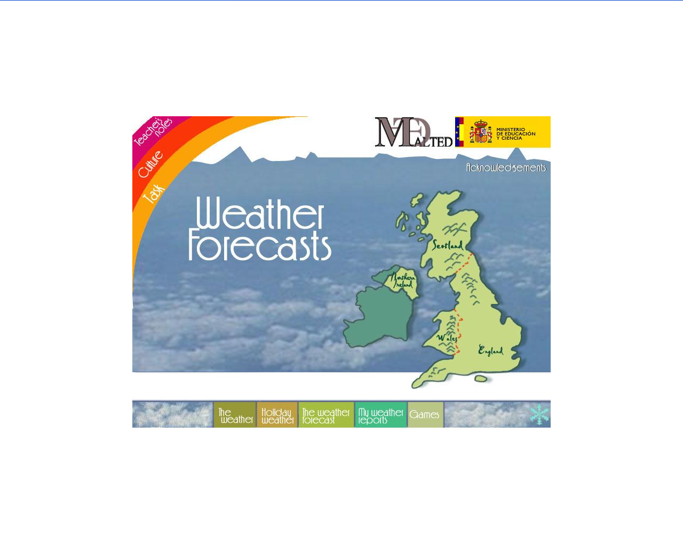

NEW VOCABULARY:

GRAMMAR:

THINGS I LIKE:

THINGS I DON’T LIKE:

DATE | CONTENTS | SKILLS | SCORE | PROBLEMS

NAME: _________________________________________________________________________________
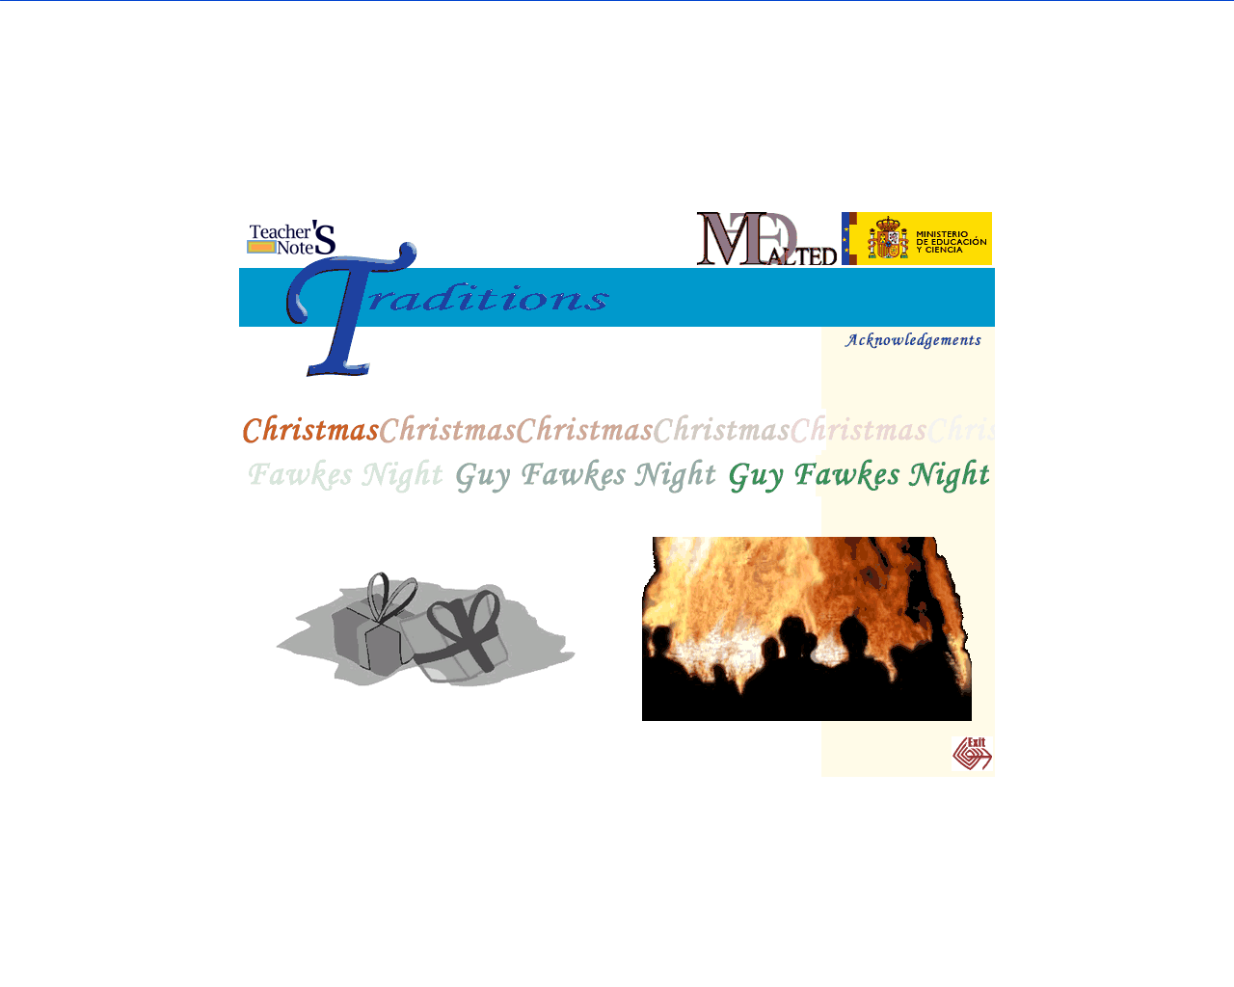
NEW VOCABULARY:

GRAMMAR:

THINGS I LIKE:

THINGS I DON’T LIKE:

DATE | CONTENTS | SKILLS | SCORE | PROBLEMS

