Name___________________________________Date_____SessionUnit____Chapter_________________
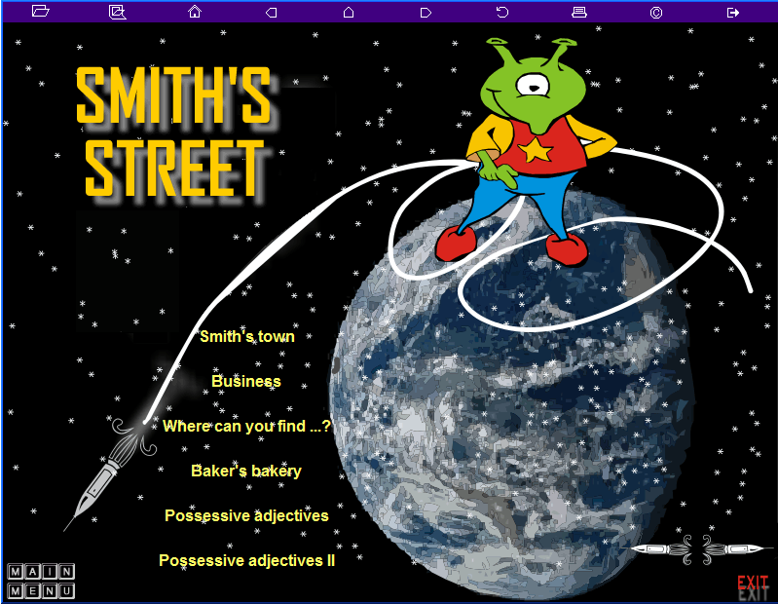
My process of learning…What I have learnt!

Grammar.

Vocabulary. Write all the new words of this chapter.

Things I enjoyed a lot

Things I do not like at all.

Technical problems.

