MAULA 09 - 2º ESO bilingüe
IES A Sangriña, A Guarda
Teacher: Rosana Moreira

TEST Units “Directions” and “The Band”

NAME …………………………………………………………………….. GROUP ……. DATE …………..…

50 points
GRAMMAR

- Underline the mistakes: Then write the correct sentences. 10 p.

- What time do Tina get up? At seven o’clock.
_____________________________
- My son not goes swimming on Sunday.
_____________________________
- Walk your sister to school? Yes, she does.
_____________________________
- My brother and my sister is slim.
_____________________________
- I go often to the beach in summer.
_____________________________

- Write the questions for these answers 10 P.

  - ..................................................... ? He’s from Glasgow.
  - ……………………………………………….…. ? My sister’s name is Jane.
  - …………………………………………….……. ? I live in Vigo.
  - ……………………………………………..…… ? Alice has got ten CDs.
  - ..................................................... ? Tim goes to bed at 23:30

3. Put the words in the right order: 10 p.

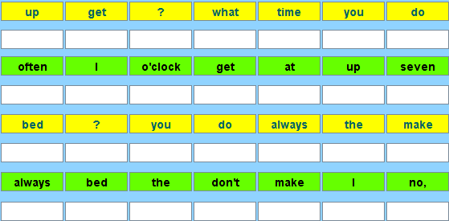
4. There is / There are. Complete the sentences: 10 p.

 |  | 
There .... a .... ........  Hay una manzana roja | There …. .......apples  Hay manzanas rojas | There ..... ....... strawberries  Hay algunas fresas
 |  | 
......... ....... a chocolate cake  No hay una tarta de chocolate | ......... ......... …….. sugar  No hay mucho azúcar | .......... ........... red deck chairs  No hay hamacas rojas
.. |  | 
....... .......... a vanilla ice-cream?  ¿Hay un helado de vainilla? | ….. ……… ……. ……… ?  ¿Hay leche? | ………………………  Hay agua

4.Translate these sentences into English: 10 p.

- Sally tiene 14 años, es de Escocia pero vive en Londres con sus abuelos. Sus padres no viven con ella.
______________________________________________________________
- Mi hijo no va al colegio andando, va en autobús con sus amigos. Se levanta a las 7. ¿Dónde está el colegio? Vete recto y tuerce a la izquierda en el segundo cruce. El cole está al lado de la oficina de correos.
________________________________________________________________________________________________________________________________

- ¿Tu padre sabe cocinar? Sí, cocina tres o cuatro veces a la semana pero nunca lava los platos.
________________________________________________________________________________________________________________________________

20 points
VOCABULARY

Music. Write the names under the pictures: 10 p.

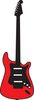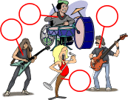
.......................... ...................... B .................. ..............................
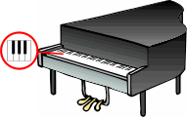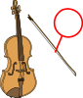
........................... ........................... ........................... ............................
 | 
  horns
  

.................... ................... …………… …………… …………….
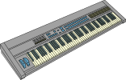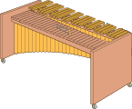
………………… ……………………. ……………………

4. Appearance: write all the possible adjectives under the pictures. You can use negative sentences if you want. 10 p.


She is…. He is..
She has got… He ..


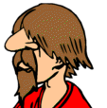







5 points
READING

Read the text about James. Then answer the questions. Write complete answers:
Macmillan Secondary Course 2, resource book

I love TV. I’m a fanatic, especially of reality shows; I watch every programme of Big Brother. My father likes to see the news, but I don’t like this programme. So, when he is watching the news, I watch the Simpsons on the other TV. He hates cartoons, so he never watches TV with me.

Once or twice a week I watch a football match on TV, and three or four times a month I watch a documentary, but I always go to the kitchen when the adverts appear.

I only watch films once or twice a year, I prefer watching comedy programmes. My father and mother like them too, so we sometimes watch them together.

- Does James like watching TV? ………………………………………………………………………………………………….
- What is his favourite programme? ……………………………………………………………………………………………
- Does his father watch cartoons with him? ………………………………………………………………………………
- Where does James go when the adverts are on TV? ……………………………………………………………
- How often does James watch films on TV ?……………..………………………………………………………………

20 points
WRITING

- The City. Write some sentences about London. Use there is/ there are and the vocabulary below: 10 p.

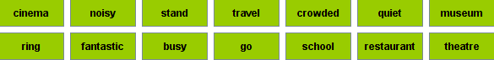

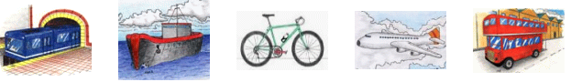

- ……………………………………………………………………………………………..………………………………………………...…... ………………………………………………………………………………………………………………………………………………….…..
- .…………………………………………………………………………………………………………………………………………………………………………………………………………………………………………………………………………………………………….………..
- .………………………………………………………………………………………………………………………………………………………………………………………………………………………………………………………………………………………………………………
- .…………………………………………………………………………………………………………………………………………………………………………………………………………………………….…………………………………………………….…………………………..
- …………………………………………………………………………………………………………………………………..…………………………………………………………………………………………………………………………………………………………………………

4. Routines     

Write a short paragraph about you daily routine, things that you do and you don’t do. Use adverbs of frequency. 10 p.
____________________________________________________________________________________________________________________________________________________________________________________________________________________________________________________________________________________________________________________________________________________________________________________________________________________________________________________________________________________________________________________________________________________________________________________________________________________________

5 points
PRONUNCIATION of CAN/CAN’T

Write the following sentences in the correct pronunciation box:

Dave can ride a bicycle - Richard can’t drive - Keith can play the guitar – They can’t play tennis – Richard can’t sing - My kids can play the piano.




