Maula 09 - 2º ESO bilingüe
I IES A Sangriña, A Guarda
Teacher: Rosana Moreira
WORKSHEET

Do you understand what the icons mean? Match:

You click on…

 …to check if you are right.
 …to leave.
 …to start again.
 …to know what you have to do.
 …when you need a dictionary

…to start the activity

… to go backward or forward

1. THE CITY
We’re going to London babe!!

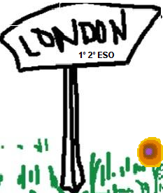
You may go to London with us after Selectividad if you get
good grades in bachillerato in A Sangriña.
Wanna come?

You’ll need some USEFUL VOCABULARY:

Complete the words:
  A_ _H |   M_S_ _M | 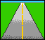  R_ _D |   _I_ _A_E |   TR_ _ F_C LI_H_
  C_U_C_ |   P_ _ _ |   S_R_ _T | 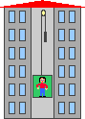  EL_V_T_R |   F_CT_ _Y
  F_RM |   C_B |   B_ _ _ |   SK_SCR_PER |   ST_R_
  LI_RA_Y |   C_ST_ _ |   T_ W_ | OB_LI_K |   P_LA_E
  B_I_G_ |   SC_ _ _L |   P_ND |   T_U_K  L_R_Y |   A_ _ _LA_ _E
  CI_E_A |   R_ _T_UR_ _ _ |   T_EA_ _ E | 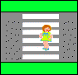  CRO_ _WA_K

Complete with the positive and negative adjectives you have studied in the Malted unit.
London is …

- … because it is full of people.
- … because it makes me feel pleased.
- … because it is full of a lot of noise.
- People in London are always doing things and moving about, it is a …. city.
- Things in London cost a lot of money, London is…….

Write about the differences between London and you village/town, use there is/are

- There is not much noise in a Guarda but …………………… in London.
- There are a lot of theatres …………… but .........………………………
- There ……. a palace called Buckingham in ………….. but ……………………………………………
- ………. ……. Lots of theatres in London but ……………………… in my village.

Now let’s practice the interrogative structure, ask your teacher about her/his town. Write the questions and answers:

- Are there any …………. in your town ? ………………………
- Is ……………………………………….. ? ………………………
- ………………………………………….. ? ………………………
- ………………………………………….. ? ………………………

2. GETTING INFORMATION First of all here is a city map for you:

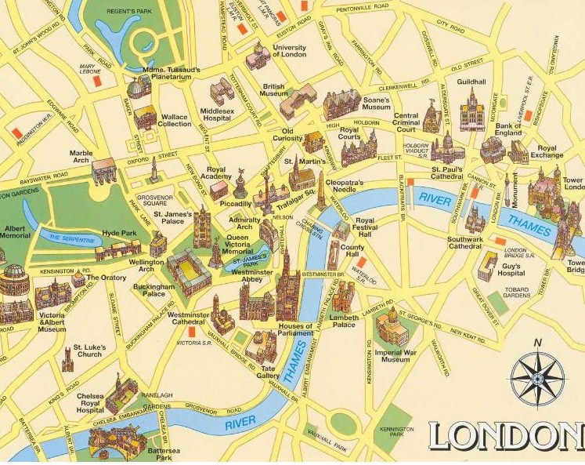

Now answer the questions and site the place or building in the map:

- Is there a cathedral in London? ……………….…………………
- Are there any parks in London? …………………………………
- Is there a castle? …………………….…………………………...
- Are there any museums? …………………….………….............
……………………………………………………………………….
- Is there a hospital in London? …………………………………...
- Is there a river in London? ………………………………………..

3. HOW TO GET TO…

Look at the map. How can we get from …. to…?

- From Buckingham Palace to the Tower of London: we can take………………….…….
- From the University of London to the British museum: we can ……………………….…
- From Victoria and Albert Museum to St. Paul’s Cathedral: we …… …… by …….……
- We can get from Regent’s Park to the Houses of Parliament ……… …………
- We travel …….. ………… from Spain to London.

EXTENSION. ASKING FOR and GIVING DIRECTIONS Look at the map. Are the
sentences true or false?

- Westminster Abbey is next to the Houses of parliament.
- Buckingham palace is between Westminster cathedral and Wellington Arch
- Marble Arch is opposite the Tower of London
- Cleopatra’s Needle is next to Victoria & Albert museum

HELP? Check this out (from http://www.learnenglish.de/PictureIt/prepositionsplace.htm )

 |  | 
The ball is in the box | The ball is on the box. | The ball is under the box.

John's house   | Jane's house   | Bill's house  
John's house is next to Jane's house. | Jane's house is between Bill's and John's houses. | Bill's house is next to Jane's house.

 |  |  |  | 
The climbers stood on top of the mountain. | The man stood between the two enemies. | The enemies stood opposite each other. | The gardners stood behind the pumpkins. | The man stood next to the gopher and held the umbrella over it.

 |  |  |  | 
The man looked through the telescope in his hands. | The man wrote the address on the package. | The man looked at the mail in the post box. | The man looked at the clock on the wall. | The manager sat at his desk on his chair.

Giving directions: Mark is at Marble Arch and he wants to go to Piccadilly Circus. Complete the dialogue with the correct words from the box.
Remember:
- We use the IMPERATIVE to give instructions and orders.
- There is no subject in the sentence.
- The form of the imperative is the same in the singular and plural
- In the negative form we use DON’T.

Straight on past left right next to opposite between on the corner crossroads

MARK: Excuse me. Can you tell me how to get to Piccadilly Circus, please?
WOMAN: Yes, of course. Go ___________ along Oxford St. Turn ____ at the second________.
Piccadilly is ________ the Royal academy.
MARK: Thank you
WOMAN: You’re welcome

NOW PLAY WITH YOUR MATES. For example:

From Piccadilly, go straight on until you come to Trafalgar Square. Then, turn left. Go past Cleopatra’s Needle and take the bridge on the right. The treasure is in the first building on the other side of the river. Where is it?

DO YOU NEED MORE VOCABULARY?

How do I get to …?
What's the best way to …?
Where is …?
Go straight on (until you come to …).
Turn back./Go back.
Turn left/right (into …-street).
Go along …
Cross …
Take the first/second road on the left/right
It's on the left/right.
straight on
opposite
near
next to
between
at the end (of)
on/at the corner
behind
in front of
(just) around the corner
traffic lights
crossroads, junction

CONCLUSION

- You use ‘there is’ with ……….……. And ‘there are’ with ……….…………….
NEGATIVE: ………………… ………………………..
INTERROGATIVE: ………………… ……………………….

- What’s your favourite activity in this unit? Why? ………………………………………………………………………………………………………………………………………………
- Was the unit very difficult to follow, why? ………………………………………………………………………………………………………………………………………………………………………………………………………………

CONSOLIDATION

Translate into English:

- No hay cine en a Guarda, pero hay varios cines en Vigo
...................................................................................................................................
- Mi pueblo es muy pequeño, pero está atestado de gente en verano porque hay dos playas maravillosas.
..................................................................................................................................
- ¿Cuántos museos hay en tu ciudad? Sólo hay un museo pero hay dos teatros.
..................................................................................................................................

EXTENSION

Are you a fast finisher? Go to http://www.isabelperez.com/some-any.htm and learn something more about grammar; or to http://www.londontown.com/ and learn something more about London.

THE END
Well done you guys!!!

