 | HOJAS DE TRABAJO
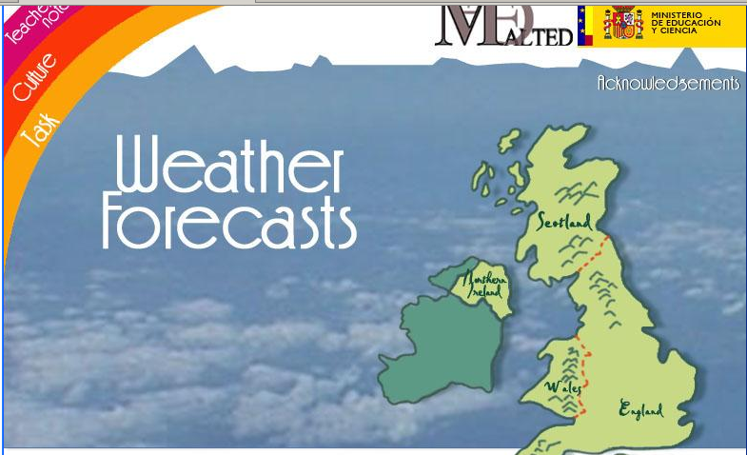
1.- WHAT´S THE WEATHER LIKE IN EACH OF THE FOLLOWING PICTURES?
1 | 
2 | 
3 | 
4 | 
5 | 
6 | 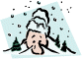
7 | 
8 | 
9 | 
10 | 

