Rosie's Family. An activity by Isabel Pérez Torres for Students in Secondary Education

WRITE THE APPROPRIATE FORM OF THE VERBS NEEDED IN THE GAPS.

Principio del formulario
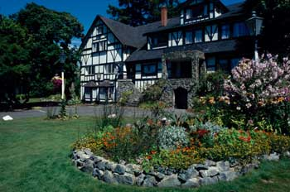
This is Rosie and her family's house. They in a small town near Brighton. Rosie with her mum, her dad, her two brothers Tom and Toni and her dog Ronny. They a big back garden with some trees. Rosie helping her mum with the garden.
Today is Saturday, at the moment she and her bedroom and her brothers breakfast in the kitchen. They bacon and eggs and every weekend they breakfast for the family.
This afternoon, Tom and Toni to Brighton to go to the cinema and Rosie at the club with her friends. Every Saturday afternoon, Rosie's mum Aunt Liza and back home for dinner. Rosie's dad usually at home and a video. At the moment, he on the phone.
Final del formulario

