1.MARK THE CORRECT WORD FOR EACH DEFINITION.

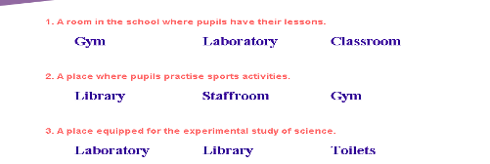
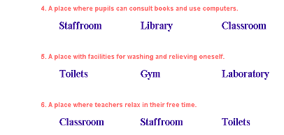

2. WRITE THE NUMBERS IN THE SPACES PROVIDED
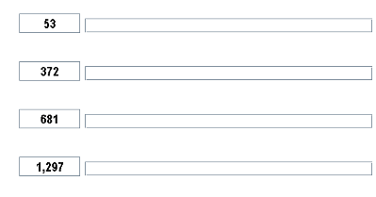
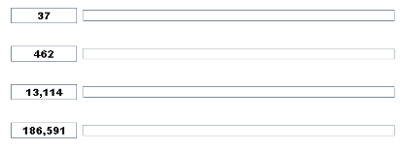

3. WRITE THE WORDS ON THE LEFT IN THEIR CORRESPONDING COLUMN

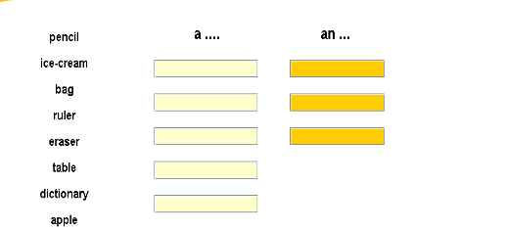

.4 a. WRITE YOUR TIMETABLE FOR THIS YEAR.

MONDAY | TUESDAY | WENSDAY | THURSDAY | FRIDAY
BREAK

b. WHICH IS YOUR FAVOURITE SUBJECT?

5.MATCH THE FOLLOWING QUESTIONS WITH ITS CORRESPONDING ANSWERS.
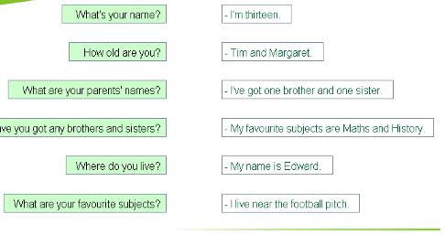

6. FILL IN THE GAPS WITH YOUR PERSONAL DETAILS
