FULL NAME………………………………………………………..DATE ……… GROUP……..
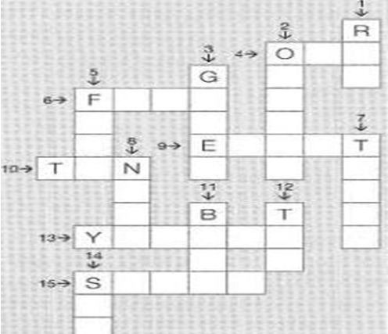
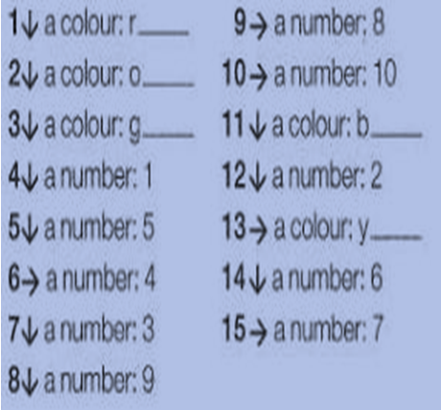
- COMPLETE THE CROSSWORD

- MATCH QUESTIONS IN COLUNM I WITH ANSWERS IN COULNM II
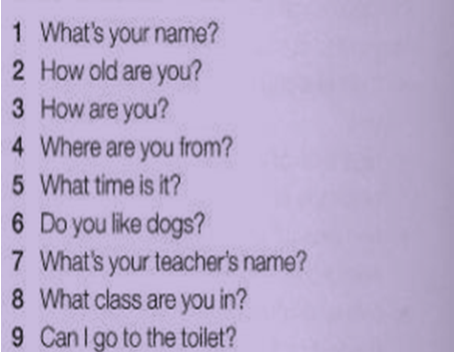
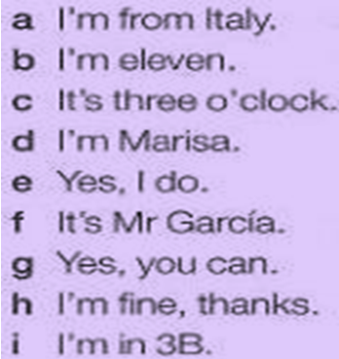

- WRITE 5 SENTENCES ABOUT YOU. THINK ABOUT:
- YOUR NAME
- AGE
- SCHOOL
- FAMILY
- LIKES

_______________________________________________________
________________________________________________________
________________________________________________________
________________________________________________________
_________________________________________________________

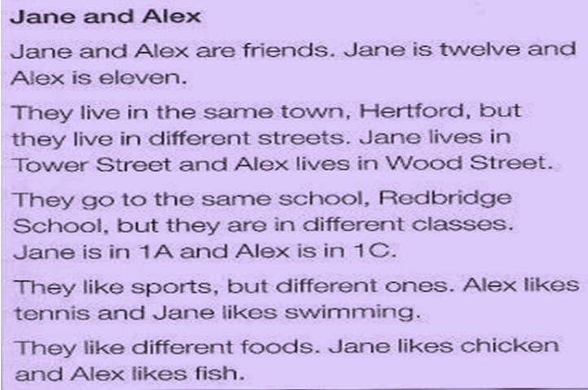
- READ THE FOLLOWING TEXT

- SAY IF THE FOLLOWING QUESTIONS ARE TRUE OR FALSE
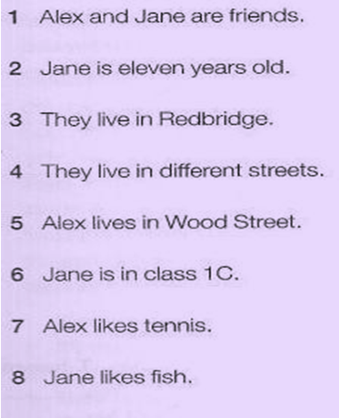
TRUE | FALSE
TRUE | FALSE
TRUE | FALSE
TRUE | FALSE
TRUE | FALSE
TRUE | FALSE
TRUE | FALSE
TRUE | FALSE

