The town Worksheet 2 Date: _________
Name: ___________________

Go to the unit The Town and do the exercises in the section At school.
Now imagine that you are the teacher and give the appropriate order in each situation:
A. One on your students in eating a cake in the class and her face is covered in chocolate.
Order 1: ______________________________________________________
Order 2: ______________________________________________________
B. It’s very hot in the classroom.
Order: _______________________________________________________
C. You are going to do a listening exercise.
Order 1: ______________________________________________________
Order 2: ______________________________________________________
D. The classroom is very dark.
Order: _____________________________________________________
E. The board is full of Maths exercises.
Order: _______________________________________________________

Go back to the unit The town and go to the section In the Streets.
Read and listen to the text about Mike and Susan and then complete the following sentences using between, near, next to, in front of, in, opposite.
1. The post office is ____________ the police station.
2. The restaurant is ______________the theatre.
3. The theatre is ___________ the department store and the cinema.
4. A ball is ___________ the toy shop.
5. A policeman is __________ the police station.
6. The pet shop is ___________ the department store.

When you finish the exercises in the section In the Streets, look at the following map and answer the questions:
1. Is the post office in front of the bus station? ________________________________________________________
2. Is the department store next to the sweet shop? ________________________________________________________
3. Is the police station between the theatre and the post office? ________________________________________________________
4. Is the bank in front of the sweet shop? ________________________________________________________
5. Is the bus station next to the church? ________________________________________________________
 |  |  | bus station |  |  | church
sweet shop | theatre |  |  | Police station |  |  | post office
bank |  | department store |  |  | restaurant

Go back to the unit The Town and do the exercises in the section At the hospital. When you finish, do the following exercises.

Look at the rules. Then complete the sentences with must or mustn’t.
Yes!  d |  | No!
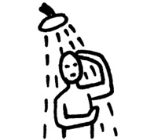 | 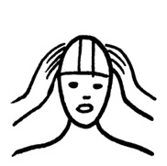 | 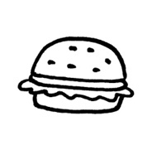 | 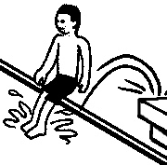 | 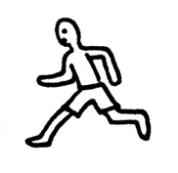
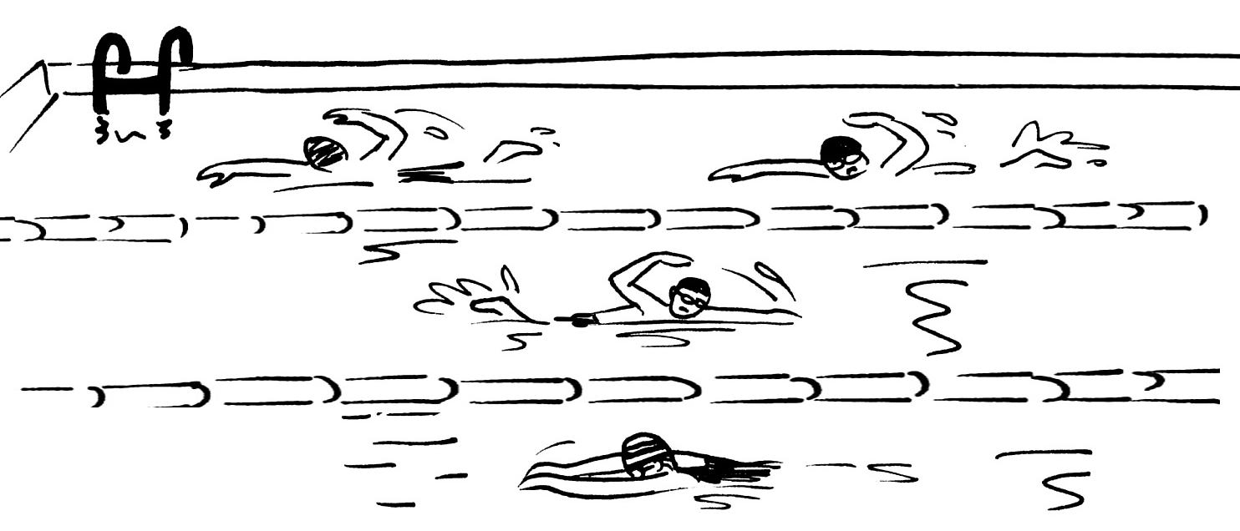

1. You ....................... wear a swimming cap.

2. You ....................... eat in the pool.
3. You ....................... run near the pool.
4. You ....................... jump into the pool.
5. You ....................... have a shower before you enter the pool.

Look at the pictures. Then complete the sentences with can or can’t:
1. Nicky ....................... walk.

2. Tim ....................... run.
Mr Samson
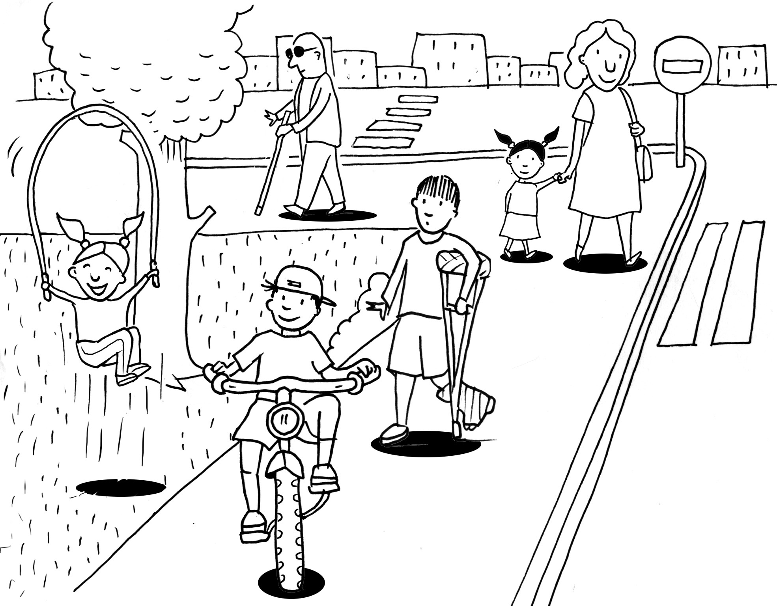
3. Benny ....................... ride a bicycle.
4. Mr Samson ....................... see.
5. Tina ....................... jump high.
Nicky

Tina
Benny
Tim

