EXPERIMENTACIÓN MALTED – PRUEBA INICIAL 1º ESO
NAME ____________________________________
1. LOOK AT THE OBJECTS AND THE PEOPLE THEY BELONG TO. WRITE SENTENCES.
 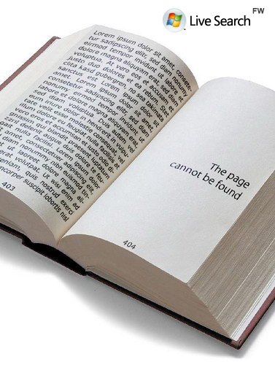 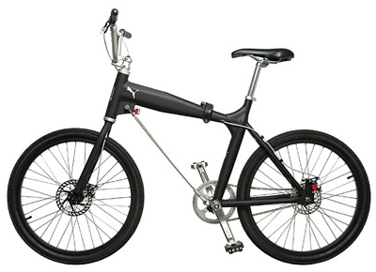   1.Ann 2. My friends 3. Mike 4. Olive 5. Mr and Mrs Johnson
Number 1 is Ann’s pencil. It is her pencil.
Number 2 …
Number 3 …
Number 4 …
Number 5 …
2. LOOK AT THE TABLE. WRITE SENTENCES ABOUT WHAT THEY HAVE OR THEY HAVEN’T GOT.
 |  |  | 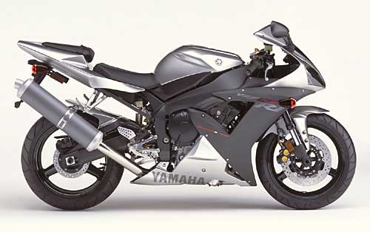 | 
I | ✓ | ✗
John | ✗ |  | ✓
My parents |  |  | ✗ | ✓
Sarah |  | ✓ |  | ✗

I __________ a computer but I ____________ a car.
John _____________________________________________________________.
My parents ________________________________________________________.
Sarah _____________________________________________________________.
3. CAN YOU COUNT THESE THINGS? WRITE COUNTABLE OR UNCOUNTABLE NEXT TO THE NOUNS
window book milk meat
pencil house water blackboard
money euro school bag dollar
desk sugar bread banana
4. CAN YOU REMEMBER THE ROOMS IN A HOUSE? WRITE THEM

HOUSE

5. COMPLETE WITH: there is / there are / there isn’t or there aren’t.
(+) ________________ a boy in the classroom.
(+) ________________ some girls in the classroom.
(-) ________________ any tomatoes in the fridge.
(-) ________________ an apple on the table.
(+) ________________ a teacher in my classroom.
(+ / -) ________________ a pencil, but ________________ a pen in my pencil case.
(+ / -) _______________ some posters but ________________ any pictures in my brother’s bedroom.
6. MATCH
a. My father’s father is my 1. brother
b. My mum’s brother is my 2. uncle
c. My parents’ son is my 3. grandfather
d. My parents’ daughter is my 4. aunt
e. My dad’s sister is my 5. sister
7. WRITE THE PLURALS OF THESE WORDS
one box / two … one chimney / two … a kiss / two …
one boy / two … one man / three … a watch / five …
one potato / four … a fridge / seven … a baby / two …
an animal / two … a body / two .. an umbrella / three …

