THE TIME / PRESENT SIMPLE 2º Fb
Name: ………………………………………… October 09

A. LOOK AT THE PRESENTATION AND WRITE THE TIMES:
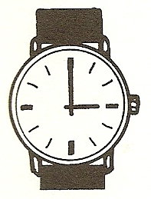  1. It is ……………………………….. | 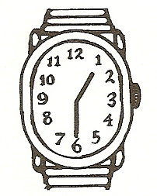  2. It is ……………………………….. | 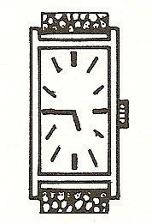  3. It is ………………………………..
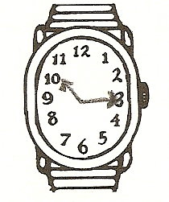  4. It is ……………………………….. | 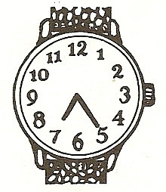  5. It is ……………………………….. | 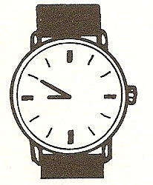  6. It is ………………………………..

B. WHAT'S THE TIME?
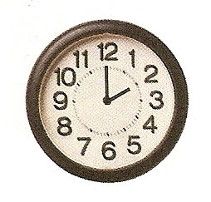  1. It is …………………………………….. | 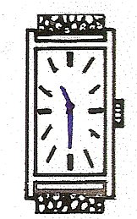  2. It is ………………………………… | 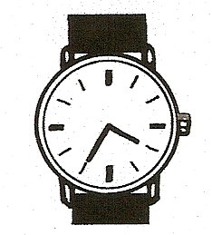  3. It is ……………………………………
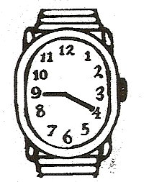  4. It is …………………………………… | 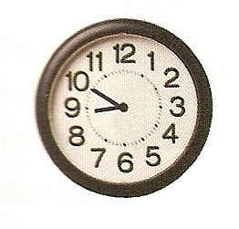  5. It is ……………………………………. | 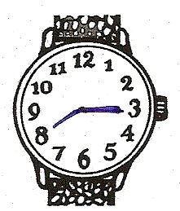  6. It is ………………………………………
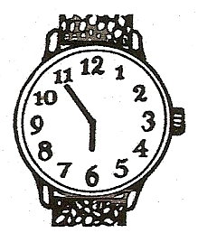  7. It is ……………………………………. | 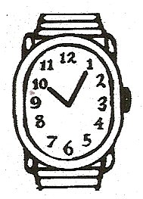  8. It is …………………………………….. | 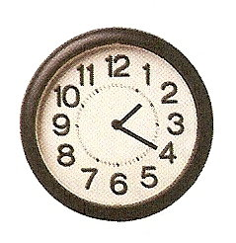  9. It is ……………………………………..

C. WRITE ABOUT PETER:

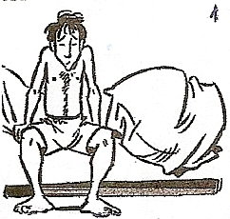  Peter get up/ 7:30 | 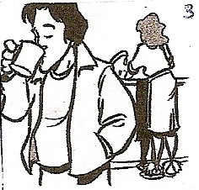  have breakfast / 7:45 | 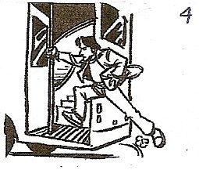  take bus / school / 8:10 | 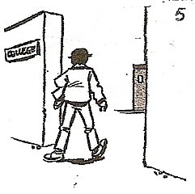  arrive / school / 8:25
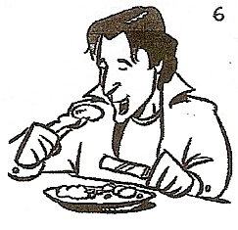  have lunch / 13:00 | 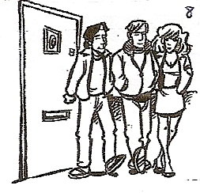  meet friends / afternoon | 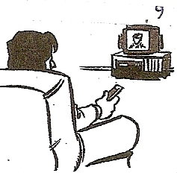  watch TV / after dinner | 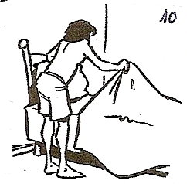  go / bed / 10:45

Peter…

