GRAMMAR & WRITING 2º Fb
Name: ………………………………………….. October 09

A. WRITE ABOUT DAN'S DAILY LIFE:
  1. Dan gets up at half past seven. | 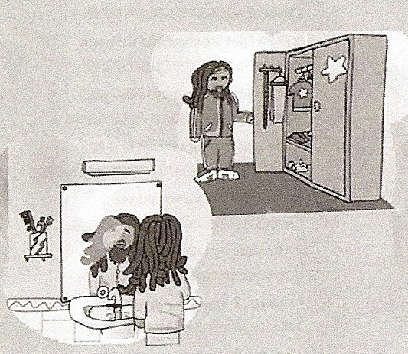  2.
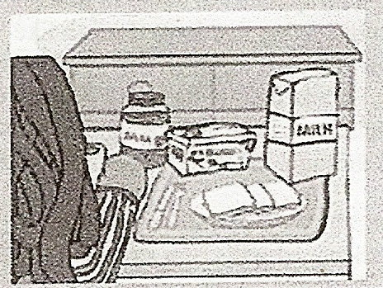  3. | 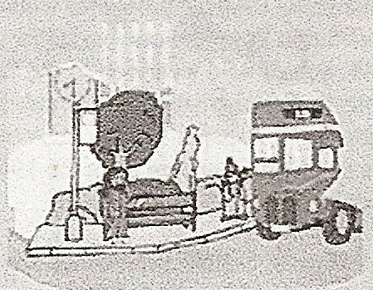  4.
  5. |   6.

  7. | 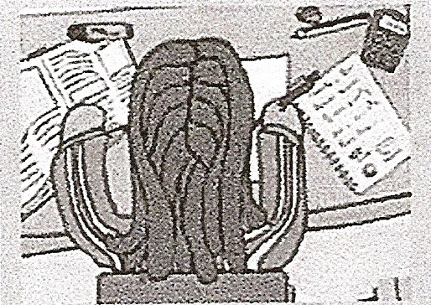  8.
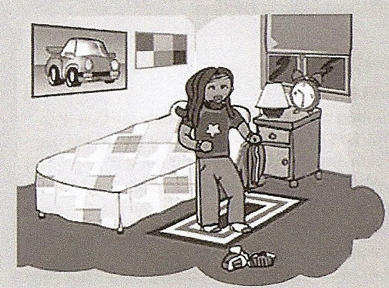

9.

B. ANSWER THESE QUESTIONS:
1. What time do you get up every day? I get up at…
2. What do you have for breakfast?
3. How do you go to school?
4. What do you do after school?
5. Do you have lunch at home?
6. Do you do your homework every day?
7. What do you do after dinner?
8. What time do you go to bed?

