“THE BAND” TEST
NAME:
DATE:

1. Write a paragraph about Dan’s routine. Use link words such as... “After breakfast, after that, then”. (8)

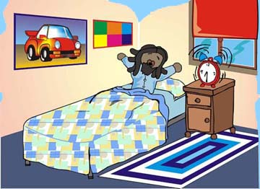 | 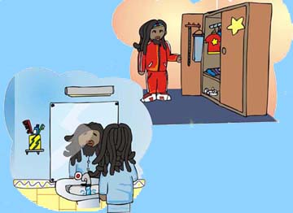 | 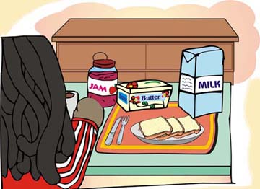 | 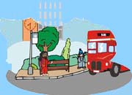
 | 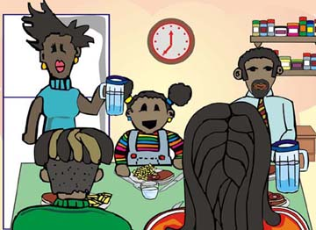 | 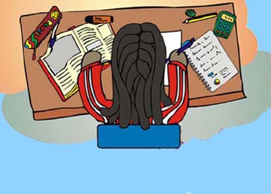 | 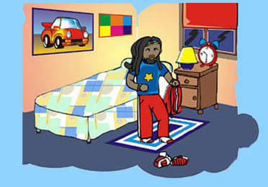

Dan gets up at -----------------

2. Write negative sentences: (4)

- We often play in the park.
- I always do my homework.
- She sometimes plays out of time.
- Dan sings very well.

3. Write interrogative sentences: (4)

- They sing in a band.
- She always remembers when to start playing.
- Bob has a shower every day.
- I get up at half past seven.

4. Match the questions to the correct answers: (5)

- Does she play the trumpet? -No, they don’t.
- Do you go to school by bus? - No, she can’t.
- Do Dan and Sally make mistakes? - No, she doesn’t.
- Does the bus arrive late? - Yes, I do.
- Can she read music? - Yes, it does.

5. Imagine you are interviewing Anna. Write the questions you ask her. (4)

You:  a. -----------------------------------------------------------?  b. -----------------------------------------------------------?  c. -----------------------------------------------------------?  d. -----------------------------------------------------------? | Anna:  a. We play rock and roll songs.  b. We usually play in village halls.  c. Sally plays keyboard.  d. I’m the singer.

6. Write affirmative or negative sentences saying what Anna can or can’t do. (4)

a. -----------------------------------------------------------------------------------------------

b. -----------------------------------------------------------------------------------------------

c. -----------------------------------------------------------------------------------------------

d. -----------------------------------------------------------------------------------------------



can  can’t
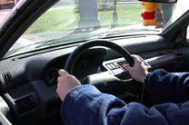   | 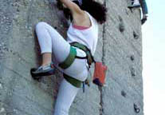   | 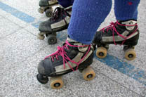   | 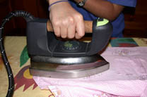  

7. Write about your daily life. (11)

TOTAL40 A:34-40 B:27-33 C:20-26 D:10-19 E:0-9

