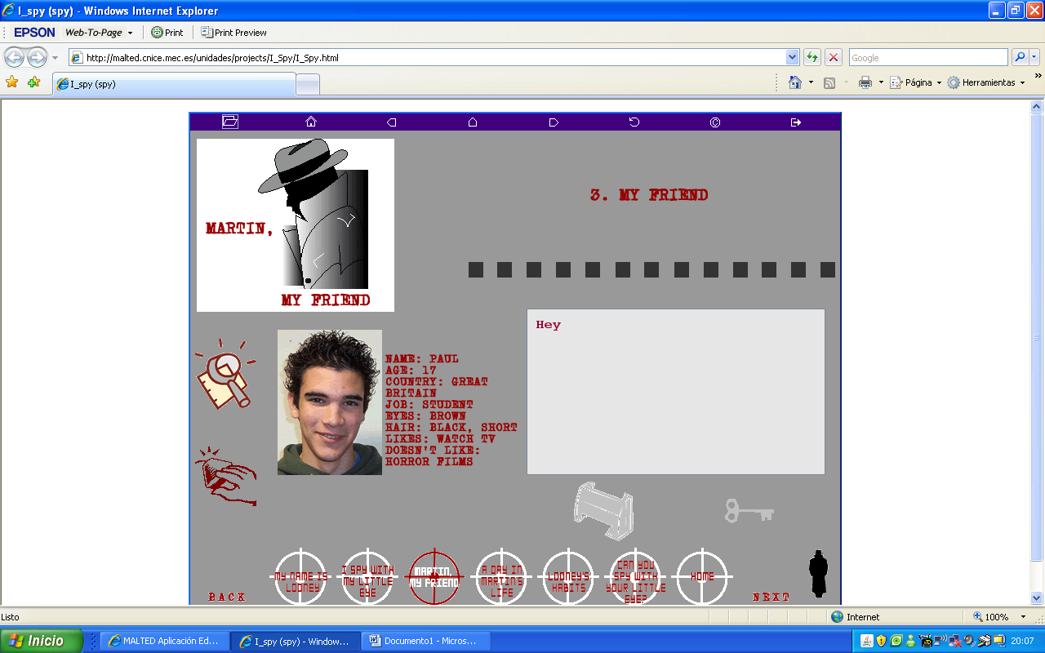
1.- Look at Paul´s information and ask a partner for the same details. When you have “investigated” everything about him or her, try to write the information following the model given:

His name is Paul. He is 17 years old. He comes from Great Britain. He´s a student. He´s got brown eyes and Black and short hair. He likes watching TV, but he doesn´t like horror films.

2.- Answer the following questions:

1.- Where does a housewife work?
2.- Who looks after patients in a hospital?
3.- Where does an astronauta travel?
4.- Does a policeman work at a police station?
5.- Who Spies on people?
6.- Where does a gardener work?

3.- Write about Helen (write the time with letters, don´t use numbers):

get up | 7.30 in the morning
have breakfast | 8.15 in the morning
go to school | 8.45 in the morning
have lunch | 2.30 in the afternoon
do homework | 5.00 in the afternoon
do exercise | 6.15 in the evening
watch TV | 8.25 in the evening
go to bed | 11.00 in the evening

