1.- Complete the following sentences in relation to the family tree:

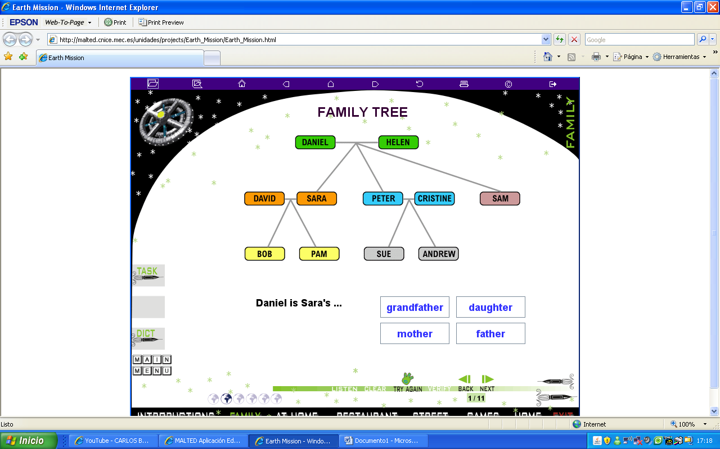

- Daniel is Helen´s __________________
- Helen is Sara´s ____________________
- Cristine is David´s _________________
- Andrew is Daniel´s ________________
- Helen is Pam´s ____________________
- Sara is David´s ____________________

2.- Describe your room following the questions:

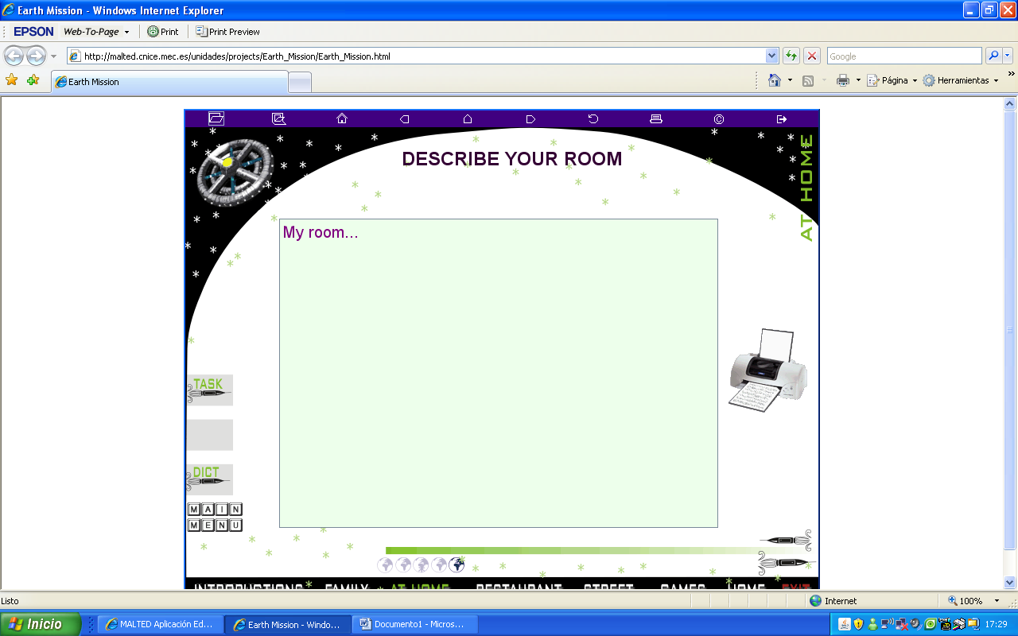

- Have you got chairs?
- Have you got a television?
- How many beds have you got?
- Have you got any windows?
- Have you got a desk?
3.- Now draw your house and name the rooms in it. Indicate who the bedrooms´ owners are.

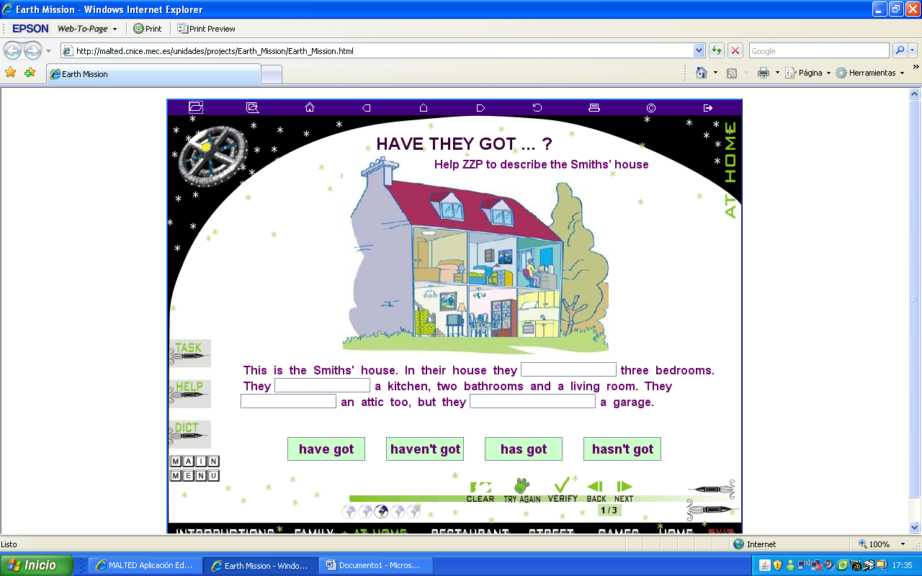

4.- Make sentences about what “I, my father, my mother, my family, and you” like(affirmative or negative), love (affirmative or negative), hate (affirmative or negative). Use the vocabulary appearing in the unit.

Example.- My father doesn´t like fast food

You don´t hate fish

