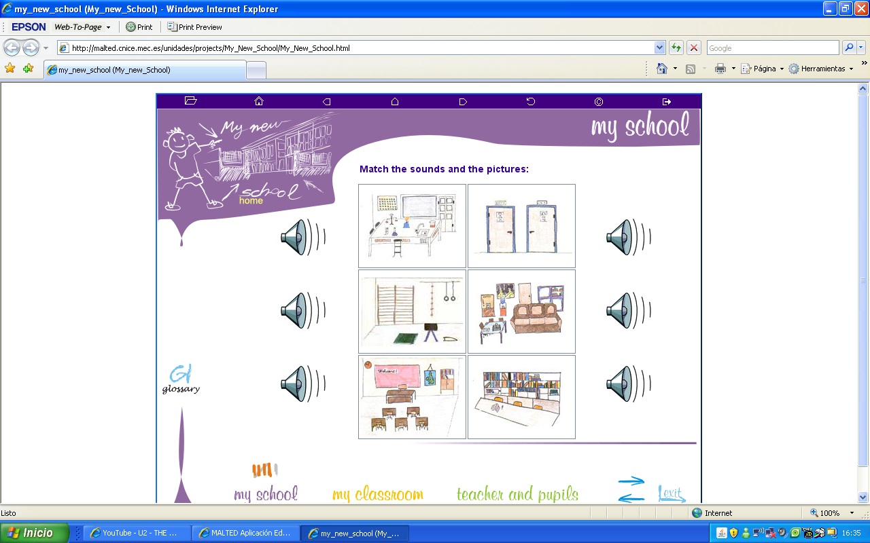
1.- Can you name the rooms in the school?

2.- Write the names of the following numbers:

58

2º

100

90

3.- Could you elaborate your timetable in English? Then tell your Partners about a specific day of the week.

MONDAY | TUESDAY | WEDNESDAY | THURSDAY | FRIDAY

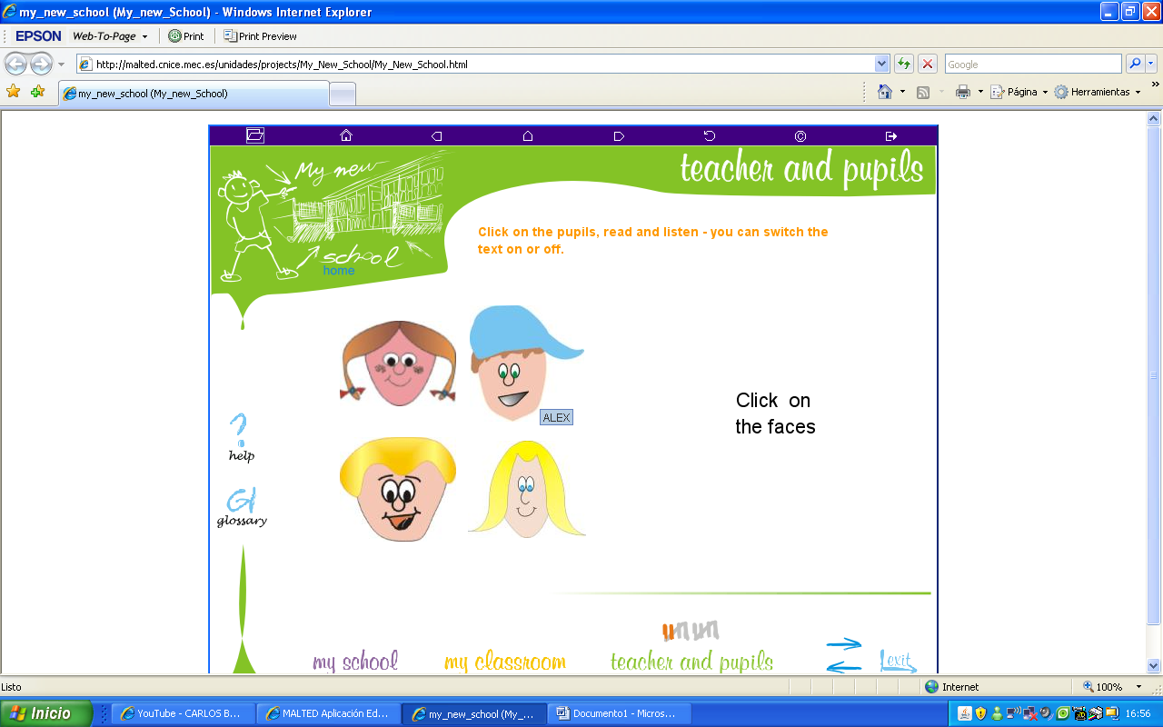
4.- After meeting them in the unit, write about yourself and then present the information to the rest of the class.

