Unit 1: Earth Mission

- Answer questions about the Jones family.
Sally Jones
Fred Jones

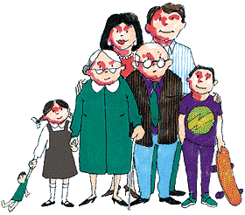
Anna Jones
Maggie Jones
George Jones
Adam Jones

- The mother´s name is ____________.
- The father´s nam is ____________.
- Who is the grandpa? ____________.
- What is Sally´s son´s name? __________.
- Who is the grandma? ____________.
- Maggie is Fred´s __________?

- What do the Jones´ have in their house?

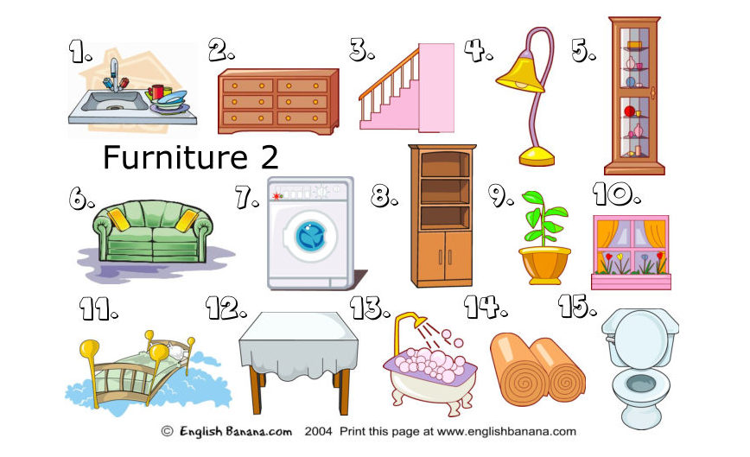

  - Have they got a toilet?
  - Have they got a couch?
  - What are two things that go in the kitchen?
  - Have they got something to wash their clothes in?
  - What is number 4 called?

- Menu and Food- What does Katies like, likes, or doesn´t like?



Hamburgers French fries
Tomato Ham
Salad Milk
Eggs Bread

- Katie ___________ hamburgers.
- Katie and her friend both ___________ eggs.
- Katie ____________ milk.
- Katie ___________ salad.
- Katie ___________ bread.

