FINAL TASK 3.
Pair work students names:

WHAT DO YOULIKE, DISLIKE, HATE ABOUT FOOD??????????
I like….. I don`t mind…..
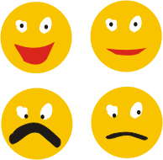
I dislike…. I hate…..
To find food and its images, click on this link and find ANY name!
http://visual.merriam-webster.com/food-kitchen/food.php

Now talk about yourself and your mate….

I like……………. My friend likes…………………..

