PC Name and Number:__________________________________
TAKE ELEMENTS FROM THE HOUSE TO MAKE YOUR IDEAL ROOM. NAME THE PICTURES AND THEN CHOOSE THEN WRITE THE TEXT INCLUDING ALL THESE ELEMENTS
IN MY IDEAL ROOM
FURNITURE
-SOFA -BED - LCD TV -HI-FI WI
-PSP SURROUND SYSTEM BOOKS CDS POSTERS
WARDROBE JACUZZI GYM SET CURTAINS LAPTOP DESKTOP

QUALITIES
NEW FASHIONABLE BIG SMALL TRENDY COMFORTABLE MODERN
OLD TRADITIONAL HOT WIDE LONG LARGE
SMALL COOL GROSS

GRAMAR COMBINATIONS
THERE IS THERE ARE I HAVE
YOU CAN FIND …..IS……… ……..ARE……
LIKE….. I DON`T LIKE………. I PREFER……

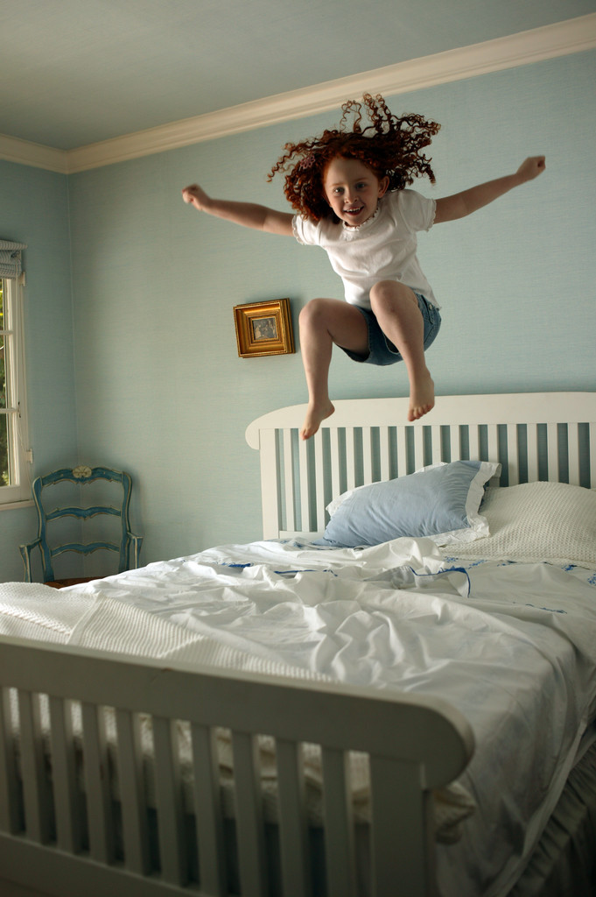


NOW USE ALL THESE COMBINATIONS TO MAKE YOUR OWN WRITTEN TEXT ABOUT IT!!

Paint it if you want!!!!

More activities??? Go to http://www.learnenglish.de/Games/Crossword5/RoomsInAHouse..htm

