

2º ESO – Directions 2 - Exam - DECEMBER 09

NAME _________________________Mark _______ /90

Reading Comprehension (15 marks)

Title:________________________________________

The people of Melbourne, Australia love food, sport and shopping! It’s a great place to eat, drink and go shopping. There are cafés, restaurants and hotels.

(a) Melbourne is a very multicultural city. People of many different nationalities live there. There are some great Italian cafés in Brunswick Street in the centre of the city. Mario’s and The Retro café are very popular. If you prefer Asian food, try the Mid City Arcade. There are some really interesting Chinese and Japanese restaurants, and great Japanese clothes shops. There’s even a Chinese chemist.

(b) If you like shopping, there are some great shopping centres, too. Try the Como Shopping Centre for shoes and clothes, and if you have got time it has got its own cinema too. But if you want to buy CDs, then there are some good music shops in Centrepoint.

(c) If you are interested in sport, then Melbourne is the place for you. People in Melbourne like to be healthy so there are a lot of swimming pools and sports centres. You can practise your favourite sports. Melbourne is famous for the Melbourne Gold Cup horse race and the Australian Open Tennis Championship. Many people come from all over the world to watch them every year.

1 Is Melbourne a good place for shopping? _______________________________________

2 What three kinds of restaurants and cafés does the writer recommend?
____________________________________________________________________________________________________________________________________________________________

3 Where are the Italian cafés? _____________________________________________________

4 What can you buy in the Como shopping centre?
______________________________________________________________________________

5 Where is a good place to buy music? ____________________________________________

6 Why is Melbourne a good place for people who like sport?
____________________________________________________________________________________________________________________________________________________________

7 What sports events is Melbourne famous for?
____________________________________________________________________________________________________________________________________________________________

8 Write a heading for each paragraph a–c in the text.
(a) __________________________________
(b) __________________________________
(c) __________________________________

9 Sum up the text in 4 lines maximum:
_____________________________________________________________________________

______________________________________________________________________________

__________________________________________________________________________

___________________________________________________________________________

Vocabulary (15 marks)

- What do these pictures show? Write the word in the box below the picture (5 marks)
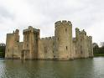 | 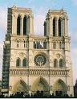 | 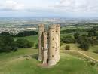 | 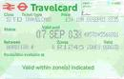 | 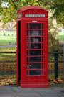
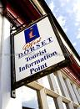 | 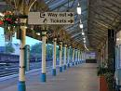 | 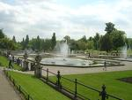 | 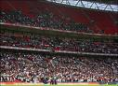 | 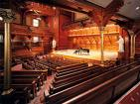

- Write a word to the definition or complete the sentence (5marks)
- An open space in a town with buildings around it: _____________________
- An atlas is a book of ____ ______________
- A model of a person or an animal made from metal or stone: ______________
- The Prado_________ ____ is a building in Madrid where you can look at famous paintings.
- A piece of paper you buy to go into a cinema or to travel: _____________

c. Complete with an appropriate word. Choose from this list: stadium/help/ visit/ busy/ rings/ crowded/quiet/fantastic/noisy (5 marks)
During lessons, when everybody is in class, the school is really ______________ and peaceful. Then, when the bell _______________ , lessons stop and the corridors of the school get very ______________ with students going from one classroom to another. At break, the cafeteria gets _____________________ with students queuing to buy a sandwich and the playground gets very _________________________with students shouting to friends, meeting and talking loudly. After break, everybody goes back to lessons and the school gets calm again.

Grammar (15 marks)

- Write sentences to describe these pictures.
Use “there is /there are” affirmative or negative. ( 6 marks)

1 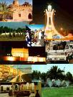 |  | 2 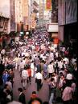 | 3  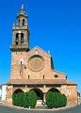 | 4 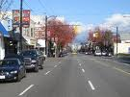 | 5  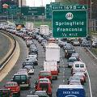 | 6  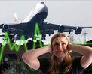
1
2
3
4
5
6

- Complete this text about transport (9 marks)
People usually travel a lot, to go to work or for pleasure. When you travel ___________, you need good walking shoes. If you want a healthy way to get to different places around a town, take some exercise and travel _______ ___________. If you want a fast transport inside a small city like Cordova you can _________ ___ ________ but it is expensive. Now, if you live far from your work, you need public transport: _____________ ______ _________, it is cheaper but don’t __________ ______ ___________ , it is usually difficult to park. If you live in a big city like London or Paris, travel ________ _______________, it is faster.

Listening comprehension (15 marks)
Complete Julia’s conversation on the phone
Julia: Hi Dad!
Julia’s dad: (1) _____________ ______________, _____________ ____________ ___________?
Julia: (2)___________________________________
Julia’s dad: (3)______________________________________________________________?
Julia: Yes, it’s great here. London (4)_____ ____ ____________________ _________ . (5)____ _______ _________________shops and (6)___________________ and ____________________ There are (7)________________________ old _________________________ everywhere and (8) _________________ and _________________
Julia’s dad: (9) _____ _________ __________________________!
Julia: Yes! But (10)_____________ _______________ and __________________ and ________
There (11) _________ _________________, (12)_________ and __________________ everywhere! It’s (13)_____________ ____________ ___________
Julia’s dad: Oh well, (14)___ ___________________ Julia and (15) ____________ _____________ ____________________!
Julia: Ok, bye!
Speaking (15)

INSTRUCTIONS: You have three minutes to complete this task with a partner

Student A: You are a tourist in Cordova.
You are at a tourist office, you want to know what places you can visit.
Student B: You work at a tourist office in Cordova. You inform a tourist.

- Greet people at the beginning and at the end of the conversation.
- Ask what places you can see in Cordoba. Talk about the opening times
- You need a map.
- Ask somebody to repeat.
- Ask information about transport and prices.
You need a transport ticket to go from the Parador to the Mosk.

Evaluation criteria and marking

Information, relevant ideas, creativity (4) | Oral communication (4)  Pronunciation, comprehensibility, fluency
Use of English: vocabulary, grammar (4) | Use of linking words: (3)  and, but, because

Writing (15 marks )
Describe Cordoba at Xmas. Use vocabulary from Directions 2 and the text about Melbourne as a model. (80-100 words) Be careful with PSP.

