MALTED EN EL AULA -VIRGINIA GARCÍA ROMERO-

STUDENT´S NAME:…………………………………………………….

UNIT: THE TOWN PART 3: AT THE STATION

1. What is Mike´s cousin name?

……………………………………………………………………………
2. Where is Mike´s cousin?

……………………………………………………………………………
3. Where does Mike live?

……………………………………………………………………………
4.
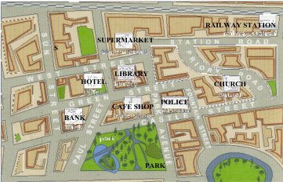

- Can you write the way from the station to the hotel?

………………………………………………………………

- Can you write the way from the park to the library?

………………………………………………………………

- Can you write the way from the hotel to the police?

………………………………………………………………
………

