MALTED EN EL AULA -VIRGINIA GARCÍA ROMERO-

STUDENT´S NAME:…………………………………………………….

UNIT: THE TOWN PART 6: AT THE CINEMA

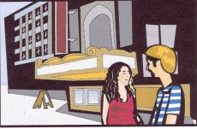

1. Where do Mike and Susan go on Saturday?

…………………………………………………………………………

2. Which film are they going to see?

…………………………………………………………………………

3. What time are they going to see it?

…………………………………………………………………………

4. Pay attention to the prepositions (AT, ON, IN). Find three mistakes in the text and circle them.

In the morning, I get up on seven o´clock. Then I have breakfast and I go

to school at eight fifteen. On the afternoon, I do different activities: on

Mondays I go to a piano lesson at five o´clock. At Wednesday I go to a

football club at half past six and on Fridays I go swimming at six o´clock.

………

