MALTED EN EL AULA -VIRGINIA GARCÍA ROMERO-

FINAL TEST UNIT: MY SCHOOL
STUDENT´S NAME: ___________________________________________________

1. Complete with there is or there are.

…………….. three pens in the pencilcase.

…………….. a rubber on the desk.

…………….. a map in the classroom.

……………... two windows in the Gym.

……………... some books in the schoolbag.

……………... a girl in the toilet.

……………... many students in the library.

……………….. there any teachers in the staffroom?

……………….. a sink in the laboratory.

2. Describe these parts of a school. Use there is/are.

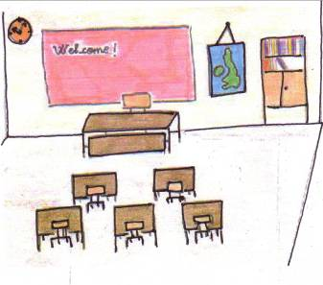

It´s a ……………………...

There …………………….

……………………………

……………………………

……………………………

………………………………………………………………………………

……………………………………………………………………………….
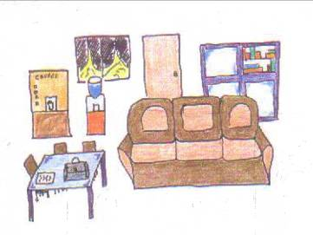

It´s a ……………………

There …………………...

………………………….

……………………………………………………………………………….

……………………………………………………………………………….

3. Complete with a, an or nothing (-)

The pupil is eating ………… ice-cream.

Sally´s sister is …………..doctor.

This is ………. eraser.

I have …………noisy classmates.

Does Jane have ………… dog?

I have found ………… ruler..

Have you ever seen ……….elephant in the book?

She is ………. Very good teacher..

That was ……… easy test.

He is ……………artist.

4. What is the ordinal name of the last object?

0 0 0
0
0 0 0 0 0
0 0 0 0 0 0 0 0 0
0 0
0 0 0 0 0 0 0 0 0 0 0 0

5. Write these numbers:

11= ………………………………………………………………………….

36= ………………………………………………………………………….

102= ………………………………………………………………………..

1,000= ………………………………………………………………………

2,546= ……………………………………………………………………..

83,200= …………………………………………………………………….

123,780= ……………………………………………………………………

5. Write about yourself: age, brothers and sisters, likes, food, lucky number, colour, favourite subjects…

------------------------------------------------------------------------------------------------------

------------------------------------------------------------------------------------------------------

------------------------------------------------------------------------------------------------------

------------------------------------------------------------------------------------------------------

-------------------------------------------------------------------------------------------------------

-------------------------------------------------------------------------------------------------------

6. Write the names of these parts of a school:

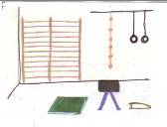


……………………………….. ………………………………..

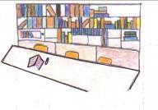
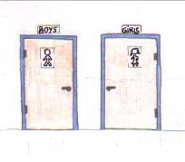

………………………….. …………………………..

7. Complete this timetable with the names of these subjects and the days of the week.

LUNES | MARTES | MIÉRCOLES | JUEVES | VIERNES
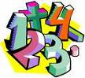 |  |  |  | 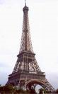
 |  |  | 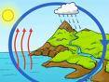 | 

