- We are going to know something else about Malted and its units.
- Open Mozilla Firefox.
- Search “ Navegador Malted”
- Click on the first website, and explore all the things you can see.
- Look for “Unidades” and click on it.
- Open 3º ESO Units, and find PIRATES. Look at the icons on your right: go over them to know what they are for. Click on
“ instalación online”.
- Follow all the installation process as your teacher does.
- Then, do the same with the unit The Four Old Friends(4º eso) and European Union (3º eso)

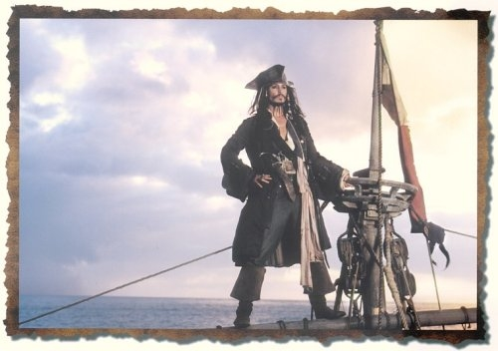

- Once we have updated the units we are going to use, it´s time to start working with them. Open the Malted icon you have on the screen( wait…it takes some time to open). You have three options: we will work with “ Mi PC”. At the bottom, on your left, look for the unit PIRATES, 3º ESO; select it and ok.

- Read the button “before you start”. What is it about?

- Revise all the icons and complete this chart:

NAME | WHAT IS IT FOR? | SYMBOL
Instructions
Help
Glossary
Menu
Exit
Back / Next

- Open the MENU to learn about the contents you are going to learn in this unit, and then complete the chart:
PIRATES : contents
READING | GRAMMAR | VOCABULARY | PRONUNCIATION | WRITING
PIRATES: Reading
- Before Reading:
  - Do you think that pirates were real or just a legend? Justify your opinion.

  - Do you know if there are any pirates nowadays?

  - Open Mozilla Firefox and look for information about “p irates in Somalia”. Check out some of the websites and try to answer these questions:
    - Where is Somalia?
    - Which are those pirates´motives?

    - Are they similar to pirates in ancient times?Which do you think the differences are?

7-After Reading: say if these sentences about the text are TRUE or FALSE . Justify your answers.
- By the end of 17th Century England and Spain were allies.

- Henry Morgan died at the prison.

- Blackbeard gave some of the things he stole with the governor.

- Ann Bonny was a friendly pirate.

- Captain Kidd was proud of being a pirate.

Self-evaluation:
- Did you read the Instructions button? Did you have to use the Spanish option to understand the task?

- How many times have you used the glossary? Write down here the words you didn´t know.
WORD ------------ MEANING

- Were you listening to the story while you were reading it, or you just read it? Was i t difficult for you? Why?

- Which part did you like the most? Why?

EXTENSION: for Fast finishers
1. Complete this chart with information taken from the text .
NAME | PERIOD OF HISTORY | WHERE DID HE / SHE ATTACK? | STORY | END

2. More vocabulary: go to the text “ Our Story”, and try to find synonyms for these expressions/words:
Francis Frolick story Lady Caroline Bridge
EVIL HAPPENED
TURNED INTO MOST IMPORTANT
CALLED

Lord Bridgewater Lord Baconfrier
CONCERNED MESSENGER
ISSUE CRIMINALS
INTENDED INTELLIGENT

GRAMMAR

            - Fill in the gaps: try to do the exercise without showing the texts. How many of your answers were right?
Right answers: Wrong answers:

Now, try again and check again.

2. Write down the SPELLING RULES for regular past verbs; use the Information button for help.

3. Exercise about regular verbs ( 3rd exercise): Did the bomb explode? How many of your answers were wrong? Can you correct them here?
WRONG ANSWERS | CORRECTION
4. ( 4TH EXERCISE) Irregular verbs: now , do the same you did in exercise 3
WRONG ANSWERS | CORRECTION

5. ( 5th exercise) Once you have ordered the words, translate the sentences of this exercise:

6. ( 6th exercise) Write questions for the answers:
- Read the Help button first.
- Then, try to do the activity without using “show me the answers”. Try at least twice. ( You can clear your answers by going back to the previous exercise, and then next again)
- Which questions were wrong? Can you write them down and try to correct them without using “show me the answers”? Think about word order in questions and verb tenses.

- Find Mistakes exercise: write down your sentences, check, and correct your errors with a red /green pen.

Do you understand why they are wrong?

FAST FINISHERS
Make correct questions for the underlined words:
1. He burnt, destroyed and killed all over the Caribbean.
2. His real name was Edward Teach.
3. He shared his booty with the governor of North Carolina.
4. People said that he buried a treasure
5. Anne Bonny escaped and started a new life.

DIALOGUE
Self-evaluation
- Did everything go right? Mention any problems you had during the exercise.

- Was your INTONATION and PRONUNCIATION very different from the original one?

- Were you surprised at your voice and intonation? Did you like it ? do you think you can improve your recording by doing it again

- Give your opinion about this activity.

LISTENING
1. Complete the chart after doing the listening activity:
How many Wrong answers? | How many Right answers? | Correction of wrong answers

How many times have you listened to it?

2. Exercise: Pronunciation of –ed ending.
Add 4 verbs to each column
/t/ /d/ /id/

