4th ESO 2nd exam 2009-10 name:……………………………………………………
Exam for the Malted Unit The Four Old Friends
Reading | Vocabulary | Grammar | Writing | Listening | Oral | Total

Reading adapted from the webpage
http://download.intel.com/education/Common/en/Resources/DEP/...

Greek Ursa Major Myths
The ancient Greeks explained the nature of the world by means of myths and legends of gods and heroes. The next story explains the shapes of two constallations Ursa Major and Ursa Minor.
The God Zeus often changed himself into various animals to carry out his plans upon mortal women. He had seduced Callisto, a nymph, and changed her into a bear to hide her from the wrath of his wife, Hera. This saved Callisto from Hera's anger, but introduced her to other dangers--now earthly hunters could take her for a common bear and attempt to kill her. One such hunter, named Actas, saw the bear Callisto, drew his bow and prepared to shoot her. Now this was an awful situation, made more terrible by the fact that Actas was the son of Callisto. To stop Actas from killing his mother, Zeus placed them together in the sky as the Big Bear and the Little Bear.
According to Ovid, the Latin writer of Metamorphoses, Zeus swung the creatures by their tails to do this, and that accounts for the fact that both the bears happen to have abnormally long tails.
- How did Ancient Greeks explain reality?
..........................................................................................................................................................................................................................................................................................
  - Why did Zeus change in animals?
..........................................................................................................................................................................................................................................................................................
  - Why did Zeus change Callisto into a bear?
..........................................................................................................................................................................................................................................................................................
  - Who is Actas?
..........................................................................................................................................................................................................................................................................................
  - Where are Callisto and Actas now?
..........................................................................................................................................................................................................................................................................................

Vocabulary:
Complete the following text with words from the box.
hunter lillies nymph pursued dasies
Callisto liked flowers, especially ……………… and …………….. . zeus had chnged the ……………. Into a bear so his wife, Hera, could not recognize her. But Callisto’s son was a …………….. and one day he ………………… his mother to kill her. Zeus felt sorry for them and changed them into Ursa Major and Ursa Minor and placed them together in the sky.

4th ESO 2nd exam 2009-10 name:……………………………………………………
Write the proper words in the gaps.
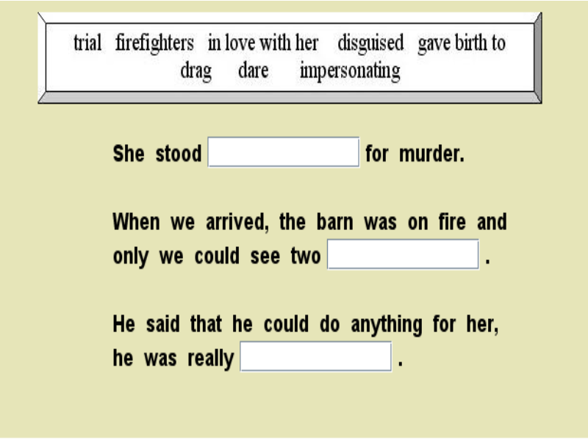
Grammar
Write the proper form of the verb in brackets or the proper form of “used to”
- They …………………. (be) friends when they ……………..(be) teenagers.
- They ……………………go to the same secondary school.
- They …………………..(meet) once a year to talk about their things.
- I ……………………(work) at a camp site last year when I met Peter.
- I ……………………(lose) my glasses. I can’t find them.
- I ……………………(see) your brother on TV last night. He ………………………… (play) against Barcelona F.C.
- I ………………………..(love) children but they ………………………..(like) me much.
- ………………………………….(you,know) the answer to these questions?
- Diane ………………………….hunt in the woods as Daphne did.
- The bird ……………………….(fly) when the hunter ……………………..(shoot).
Listening http://www.youtube.com/watch?v=-MR1q3LZ_4M

Echo and Narcissus
- Echo loves dancing talking walking
- Narcissus loves Echo himself Hera
- Her got angry at Echo and from then on
She could not repeat words / she repeated the last words she had heard / could not talk.
- He hid in the cliffs the woods the city
- Narcissus became a pond a pool a flower.

Writing.
Write about an important day in your life. Tell me when it happened, who you were with, what the situation around you was and why it is important for you. (100 words)

