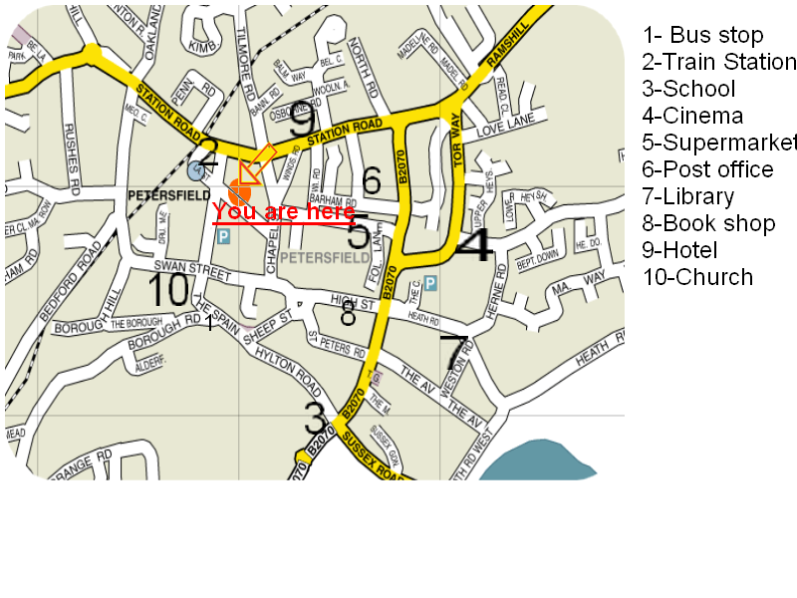
4th ESO 3rd exam 2009-10 name:……………………………………………………
Exam for the Malted Unit Directions
Reading | Writing | Vocabulary | Grammar | Listening | Oral | Culture | Total
Reading Read the instructions and tell me where I get to?

- Turn right into Chapel Street, take the first left, go straight on, go past the bookshop, then left, then right. What can you see in front of you?...............................................
- Turn left into Chapel Street, then take the first right. Go straight on. It’s on your right at the corner of Fol. Lane. What can you buy there?.................................................
Writing
Excuse me, how do I get to the school?
...........................................................................................................................................................................................................................................................................................................................................................................................................................................................................................................................................................................................................................................................

Vocabulary
Rewrite the sentences fitting in right adverb.
rather, quite, cheaply, often, pretty,
- It is only £1, it is cheap.
…………………………………………………………
- I come to school at 8:25 a.m.
…………………………………………………………
- He’s tall, he’s 1.80 m.
…………………………………………………………
- The bus will take you there , the ticket is £1.20.
…………………………………………………………
- I feel hungry. I have had nothing to eat.
…………………………………………………………

Listening. A day in London. From the unit Directions_4.
- How many times have Anna and Mike been to London?
…………………………………………………………………………………………..
- What did they ask for at reception?
…………………………………………………………………………………………..
- What time was the changing of the guard?
…………………………………………………………………………………………..
- Where did they go at 12:00?
…………………………………………………………………………………………..
- When they got lost, they wanted to know how they could get to …………………………… .

Oral
With the pojection of the map of Petersfield explain how to get to different places.

Culture

Match the beginnings and endings of the famous places in London.
St. Paul |  |  | Parliament
Trafalgar |  |  | Cathedral
Regent |  |  | Square
Houses of |  |  | Street
Westminter |  |  | Bridge
Buckingham |  |  | Abbey
Tower |  |  | Palace

