FOLLOW-UP SHEET: UNIT “TRAVELLING ABROAD”

NAME

PART 1: COMPANIONS

Find 10 adjectives of personality in this wordsearch:

T | H | B | C | B | W | K | S | Q | U | I | E | T | L
H | L | E | Q | K | D | J | Q | E | W | Q | U | U | V
N | W | V | E | M | K | O | M | U | R | Q | D | R | S
L | E | F | B | U | T | S | C | X | B | I | D | B | T
R | G | E | U | I | N | A | K | J | C | J | O | B | B
Q | E | T | Z | N | I | F | L | Z | S | Q | B | U | E
E | Z | X | C | C | N | Y | R | K | V | E | V | Q | S
Z | K | Y | T | R | L | Y | Q | I | A | P | P | O | J
H | S | H | Y | R | Y | A | B | F | E | T | D | W | U
G | Q | L | J | J | O | G | Z | E | P | N | I | I | R
G | E | Z | A | E | Q | V | L | Y | H | X | D | V | H
E | R | I | W | B | T | O | E | U | W | B | S | L | E
Q | J | M | E | A | N | W | Y | R | T | W | T | V | Y
M | G | E | N | E | R | O | U | S | T | P | X | B | U

1. 6.
2. 7.
3. 8.
4. 9.
5. 10.

Answer the following questions:
What does Frank think of Spanish people?

Where does Marcella want to travel and why?

What’s Vince like?

Who would like touring and where?

Cross out the odd one out
// rational vivacious excitable

PART 2: EXPERIENCES

Answer these questions:
Why did Derek phone Mary?

What activities are there in ESL Summer Camp?

Are meals included in the price in the Summer Camp?

What introductory verbs can you use to report questions?

Put into reported speech the following sentences:
The instructor told us, “Don’t go near the warning signals”.

The instructor ordered us, “Row faster if you want to arrive in time”

While Derek was in the camp, he had an accident. What happened to him?

PART 3: ADVICES AND SUGGESTIONS

Tick the British food recommended to Spanish people coming to Britain?
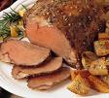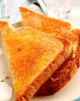
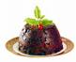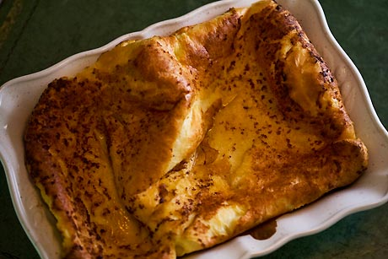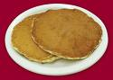

Write an example of a reported sentence following this structure:

Verb+object+infinitive

Look for the answer to this question:
What did the guide remind us?

When you are complaining about something, what are you doing?

Which of these sentences is not a suggestion?

“Let’s go to Spain”
“We shouldn’t go to a very hot country”
“We all agreed to go to bed”
“Why don’t we talk about it tomorrow?”

PART 4: EXTENSION

Which phrasal verb would you use in these pictures?



EXTRA

Which part of the unit does the expresion “off the beaten track” appear? What does it mean?

